**Binary Trees**

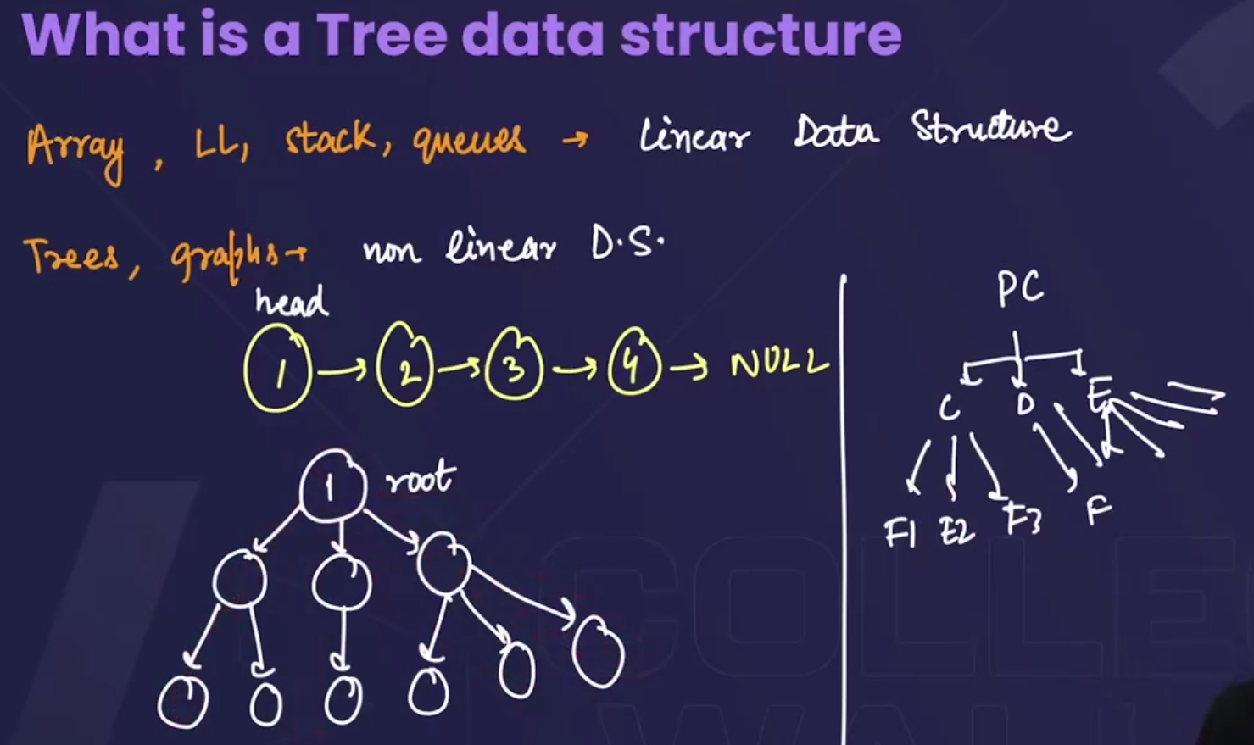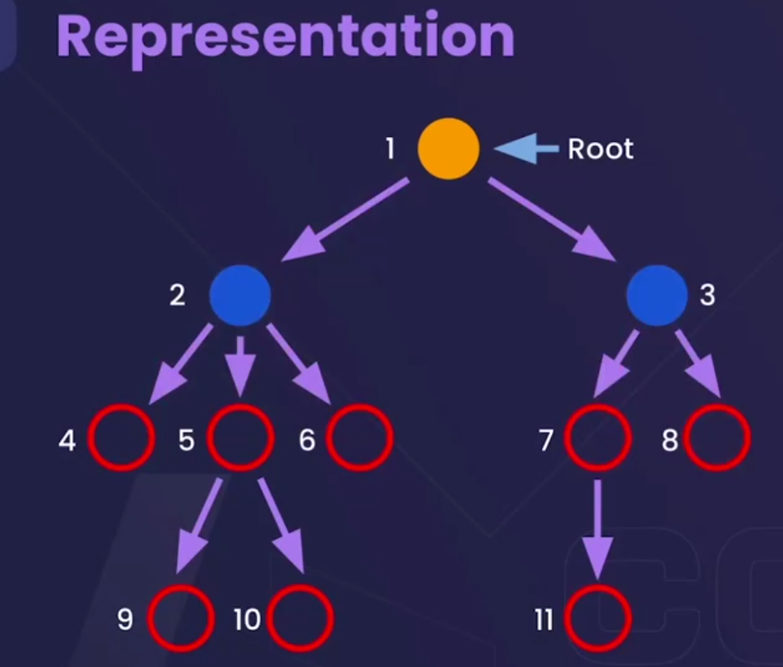

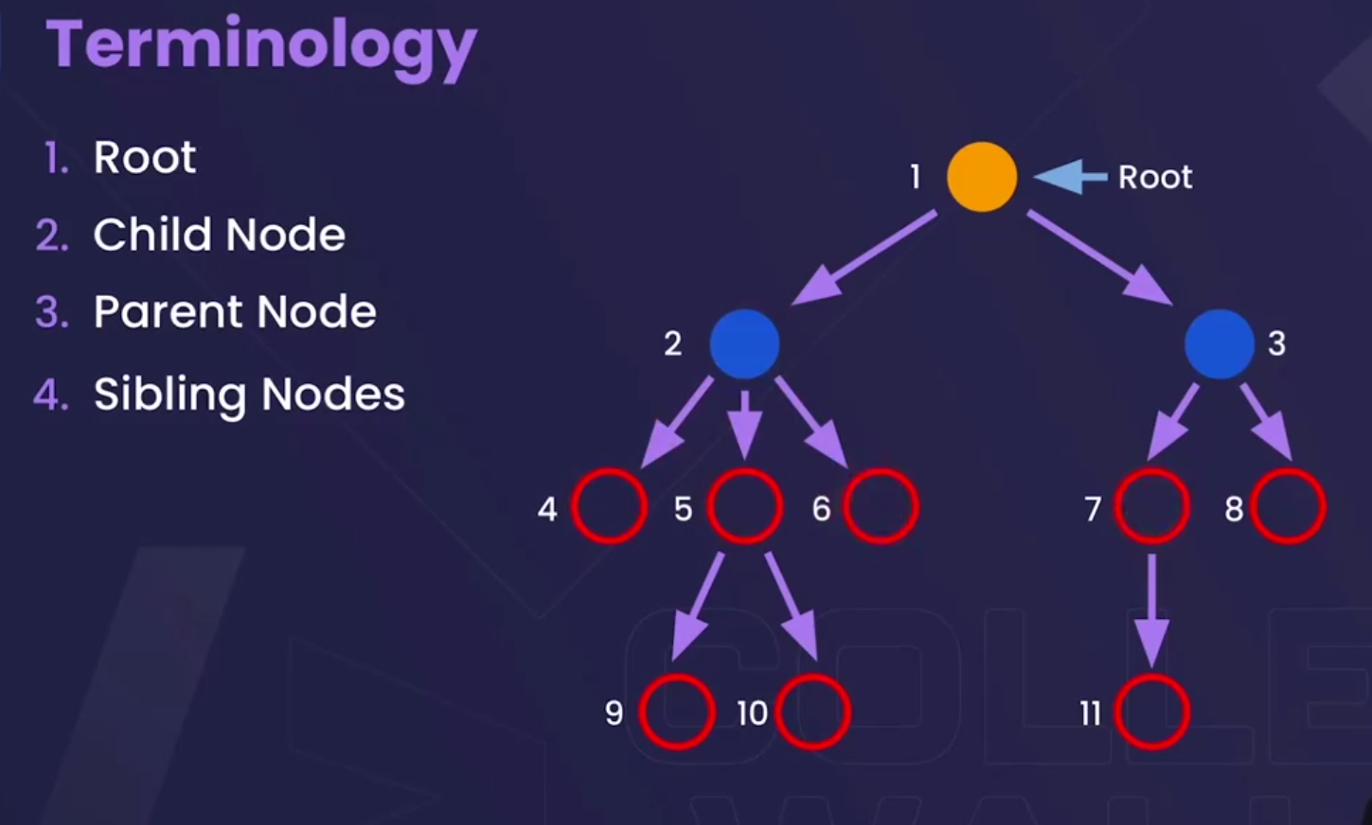

* **Root** → The topmost node of a tree.
* Example: 1
* **Child Node** → A node that comes from another node (its parent).
* Example: 2, 3 are children of 1.
* **Parent Node** → A node that has one or more children.
* Example: 2 is the parent of 4, 5, 6.
* **Sibling Nodes** → Nodes that share the same parent.
* Example: 4, 5, 6 are siblings.

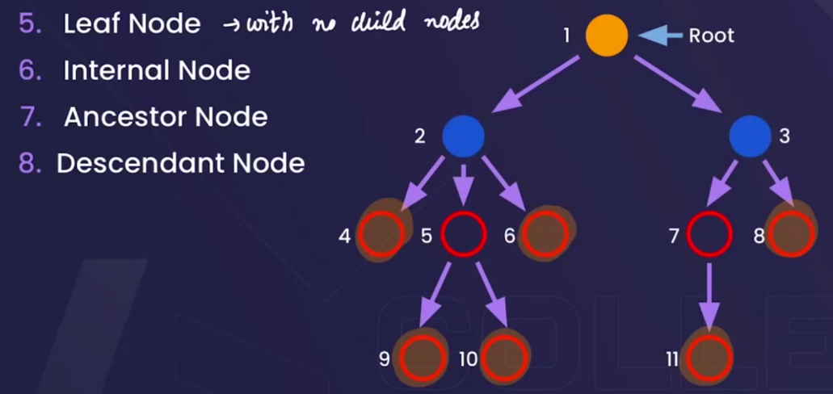

* **Leaf Node** → Node with **no child nodes**.
* Example: 4, 6, 9, 10, 11
* **Internal Node** → Node that has **at least one child** (not root, not leaf).
* Example: 2, 3, 5, 7
* **Ancestor Node** → Any node on the path from the root **to a given node** (including root).
* Example: Ancestors of 10 are 1 → 2 → 5.
* **Descendant Node** → Any node that comes **below a given node**.
* Example: Descendants of 2 are 4, 5, 6, 9, 10.

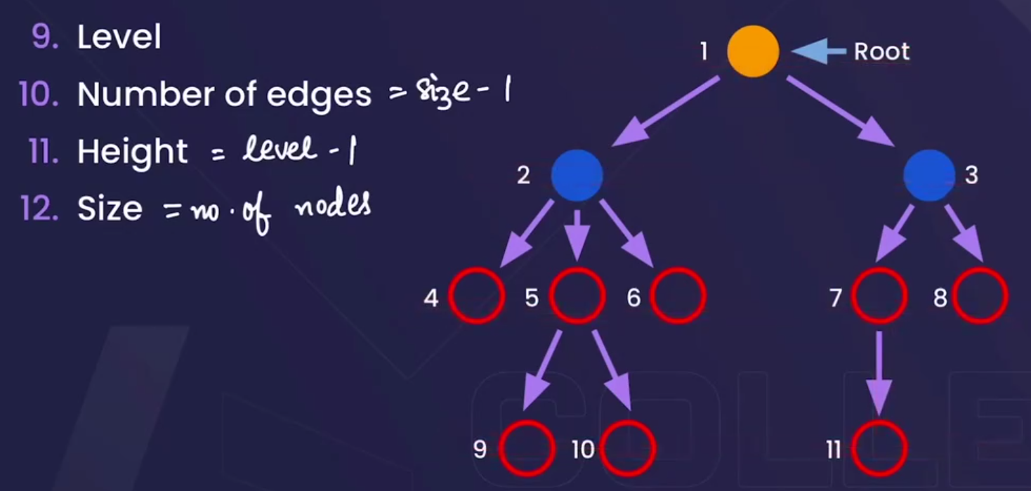

**9. Level** → Distance from the root (starting at 1 or 0 depending on convention).

* Example: Root 1 is at level 1, nodes 2,3 at level 2, nodes 4,5,6,7,8 at level 3.

**10. Number of Edges** → In a tree, always = **Size − 1** (nodes minus one).

* Example: If 11 nodes → edges = 10.

**11. Height** → Maximum level − 1 (longest path from root to any leaf, in terms of edges).

* Example: Height of this tree = 3 (path 1 → 2 → 5 → 9).

**12. Size** → Total number of nodes in the tree.

* Example: Here size = 11.

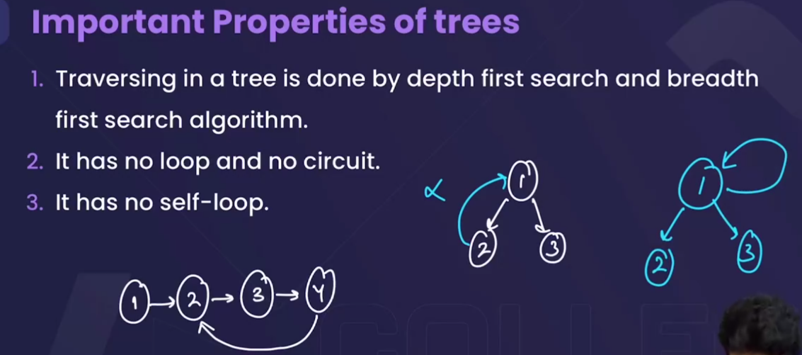



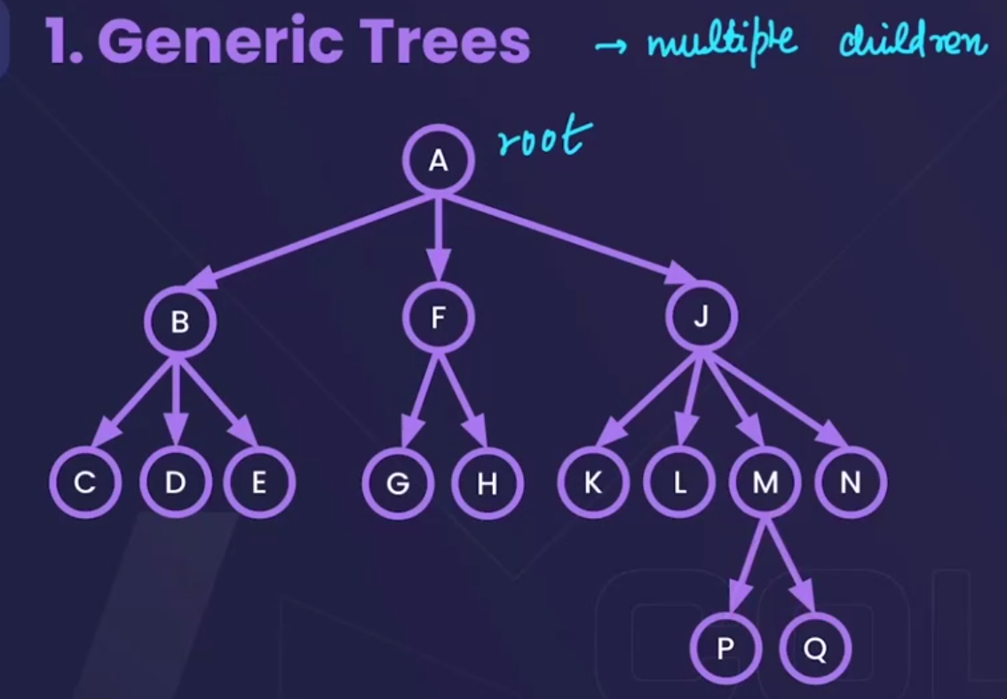🡪ek parent k kitne bhi children ho skte h 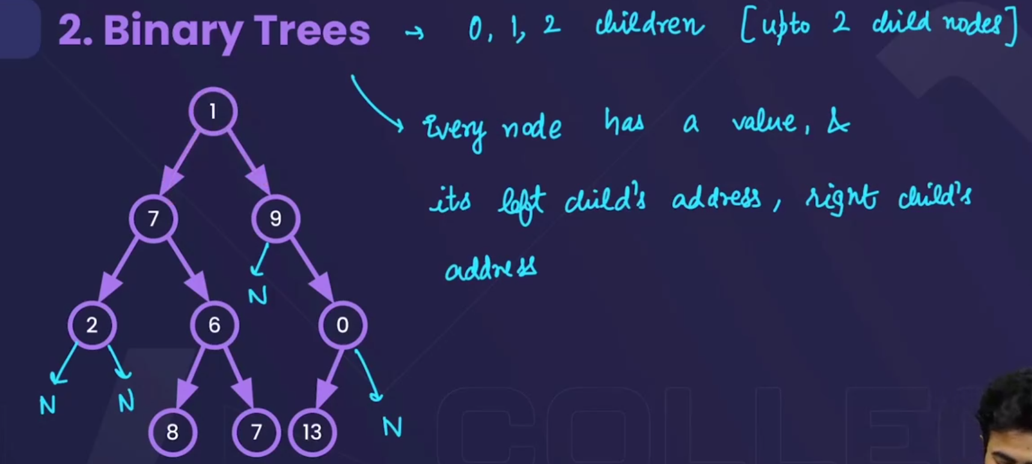

* Can have 0,1 or 2 children.

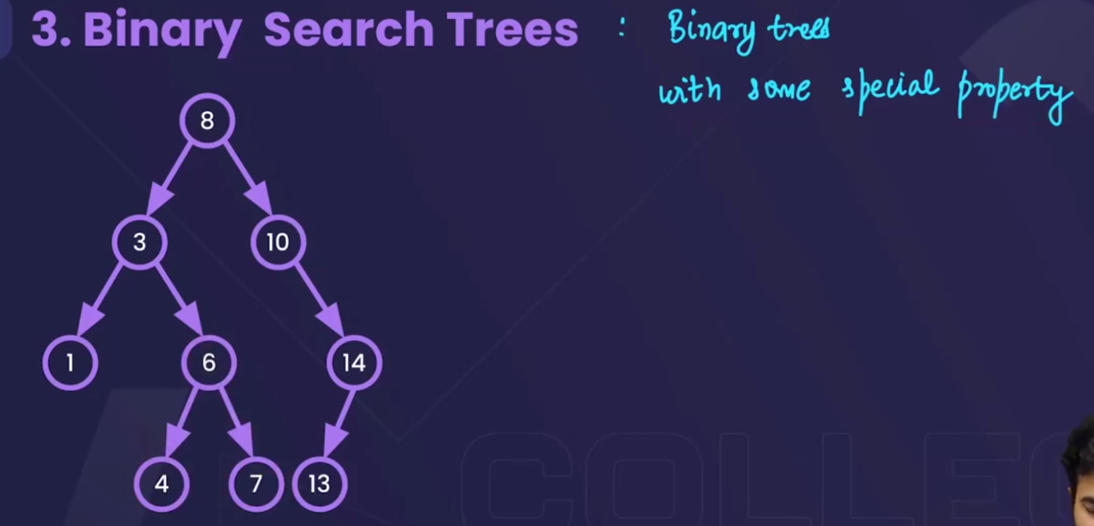

* Binary search trees are the special binary tress in which, kissi bhi node k left m jo node h woh chota hoga uss node se and right m jo node h who bada hoga uss node se.

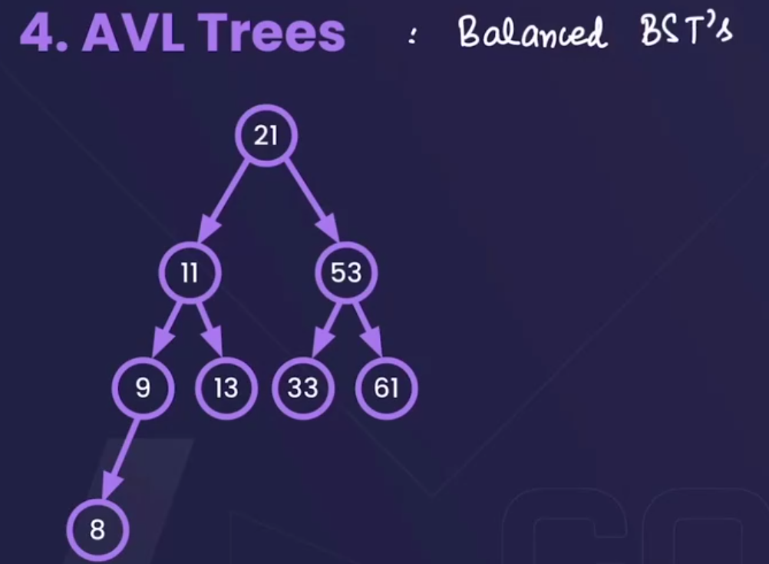🡪 these are the balanced BST’s.



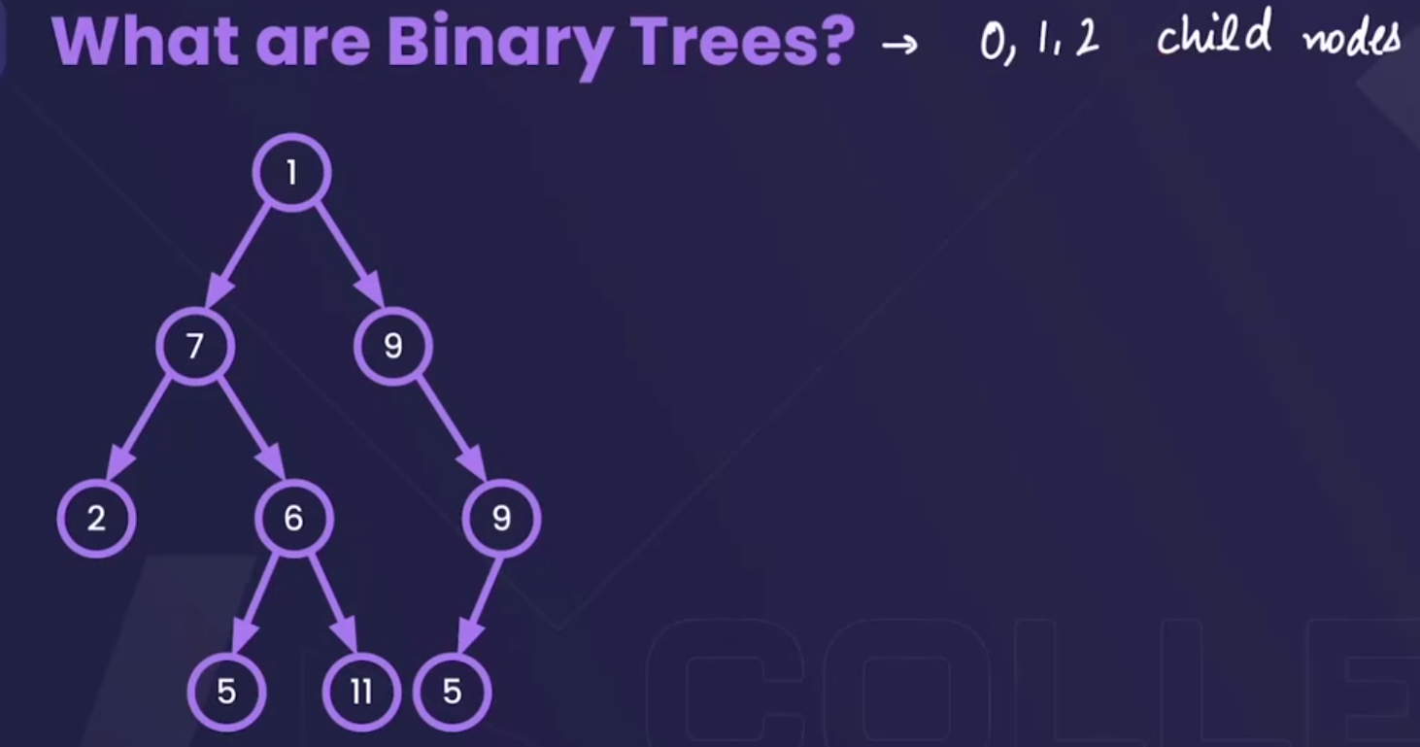

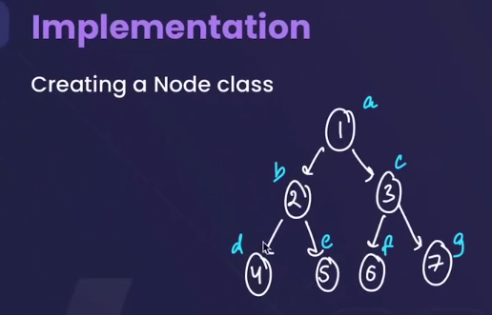

* To build this tree :

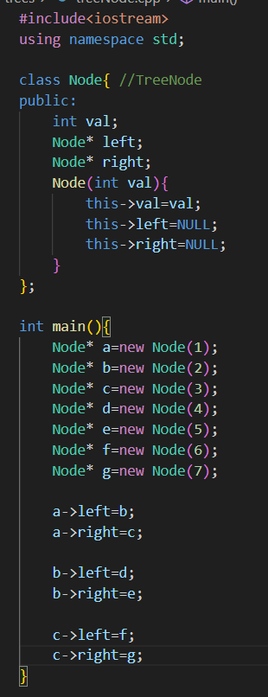



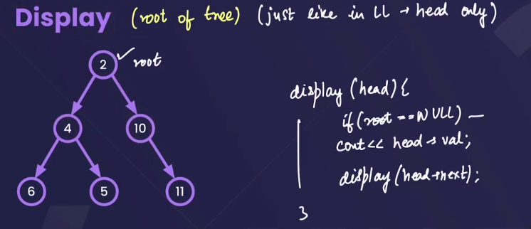



* We will be give the root of the tree only(as we given only the head in the linked list).
* In linked list we use to display like this & in the similar manner we will display a tree.
* 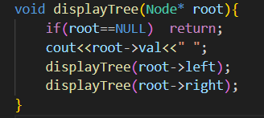

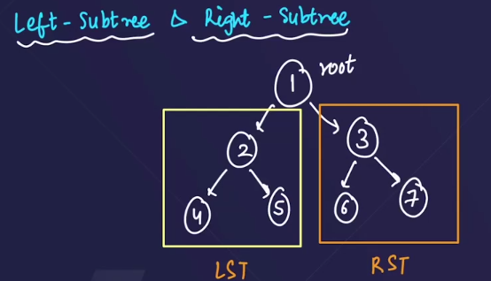 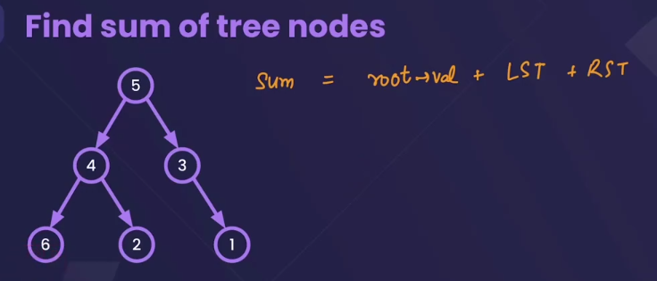-> 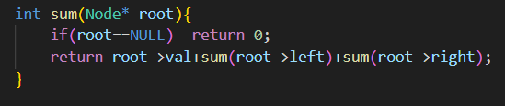

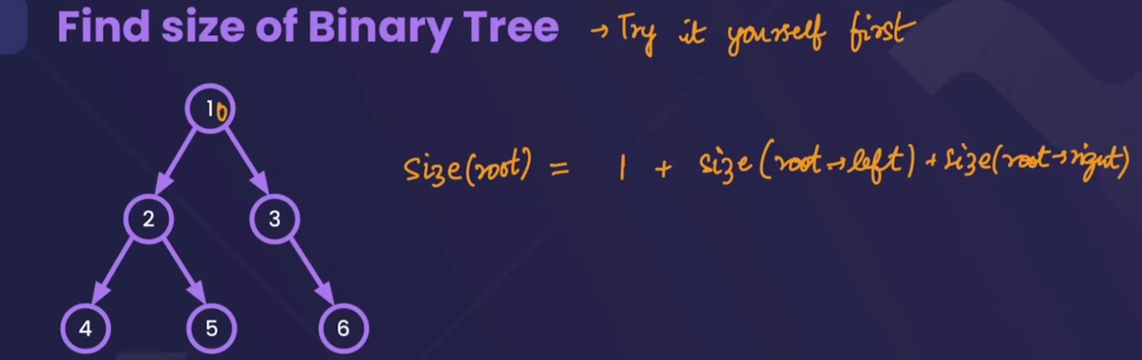-> 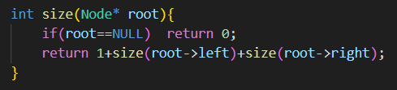

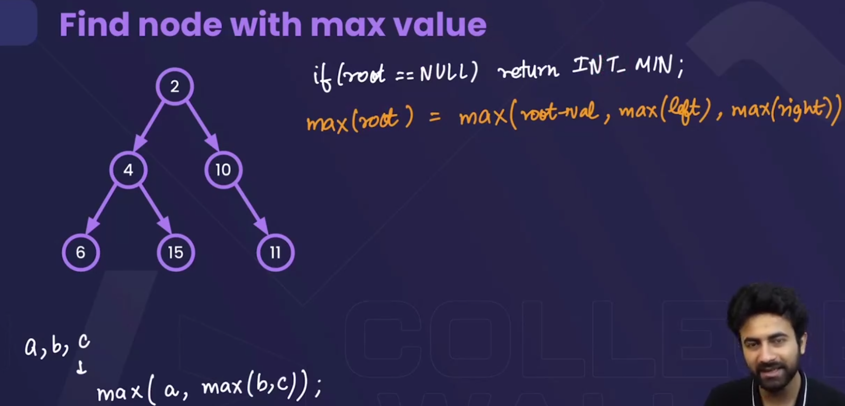-> 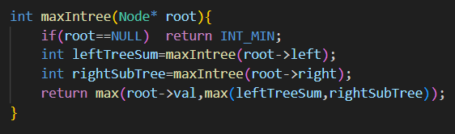

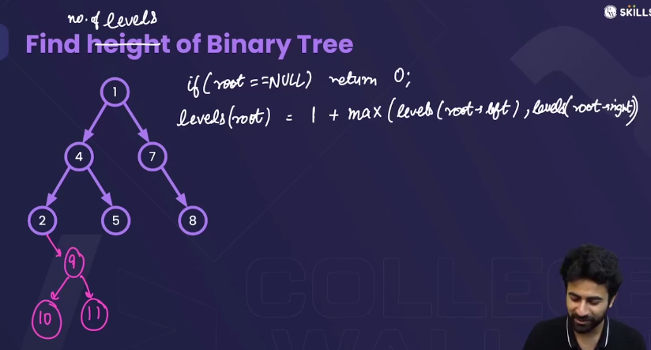-> 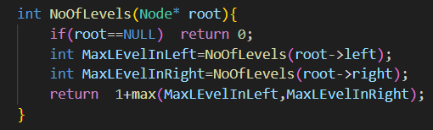



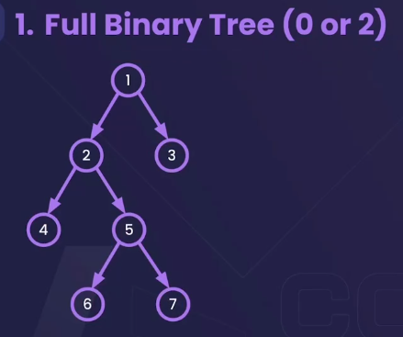->a binary tree having either 0 or 2 children. 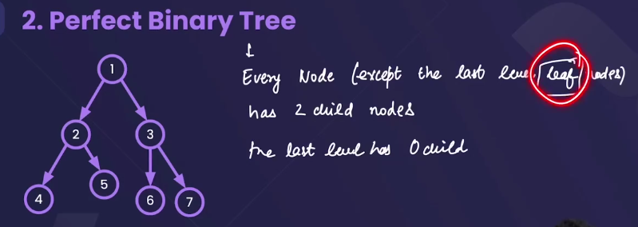 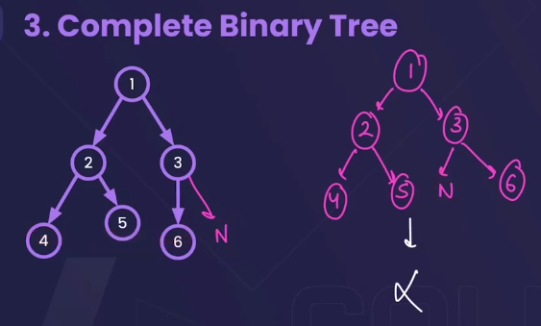

**✅ Complete Binary Tree**

A binary tree is **complete** if:

1. **All levels are completely filled**, **except possibly the last**.
2. In the last level, all nodes are filled **from left to right** (no gaps in between).

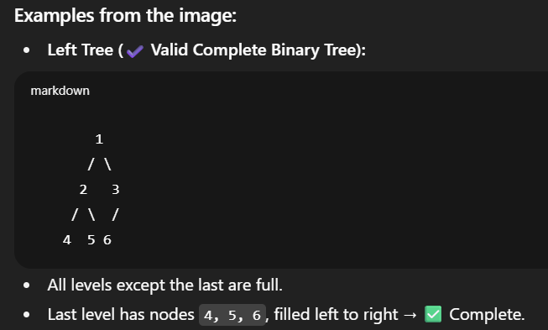 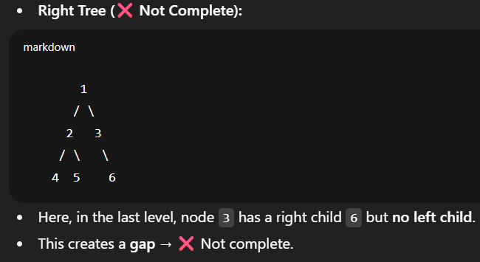

👉 In short:  
A **complete binary tree** has nodes filled **level by level, left to right, without gaps**.

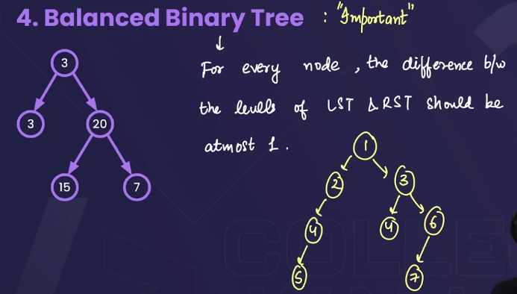 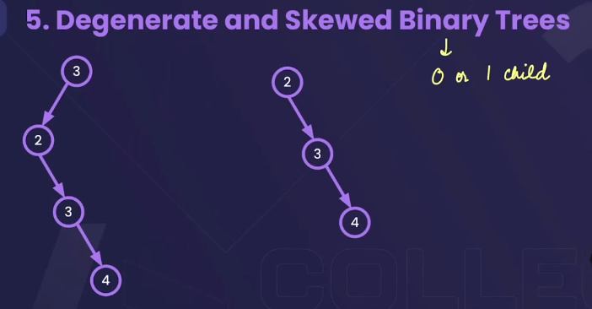

 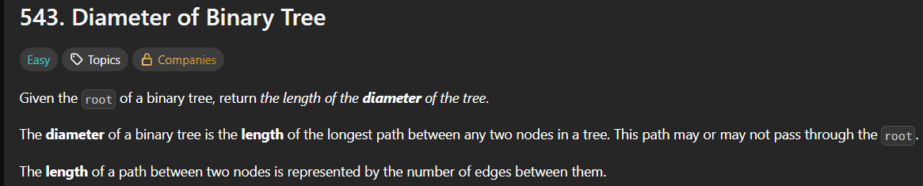 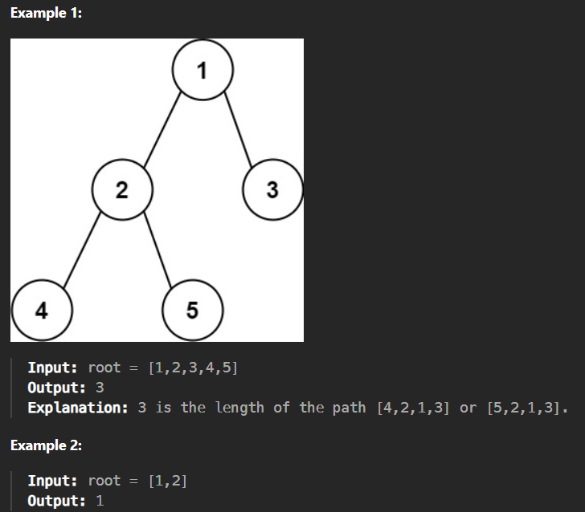

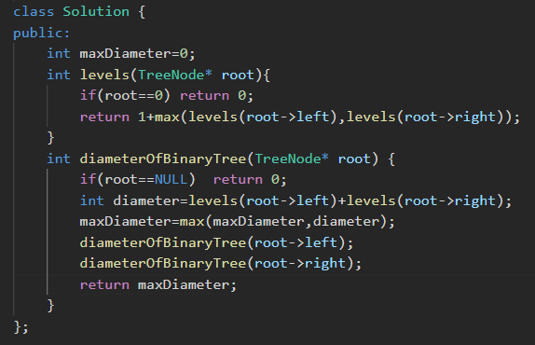 or, 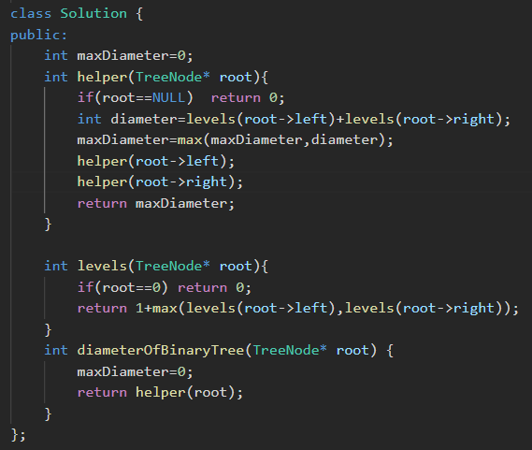



* Interviewers don’t like a global variable.

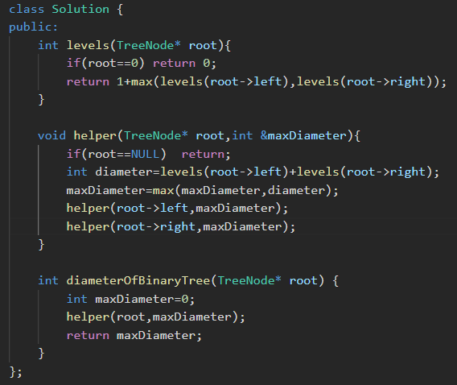

 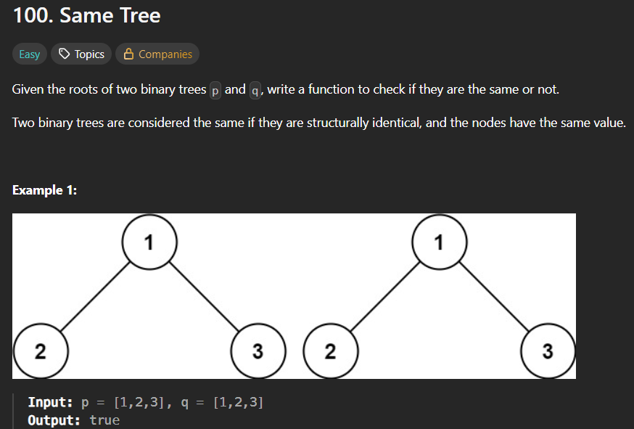 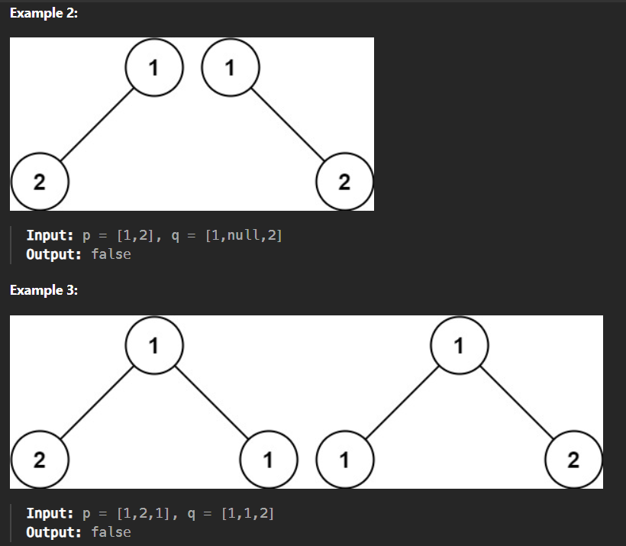 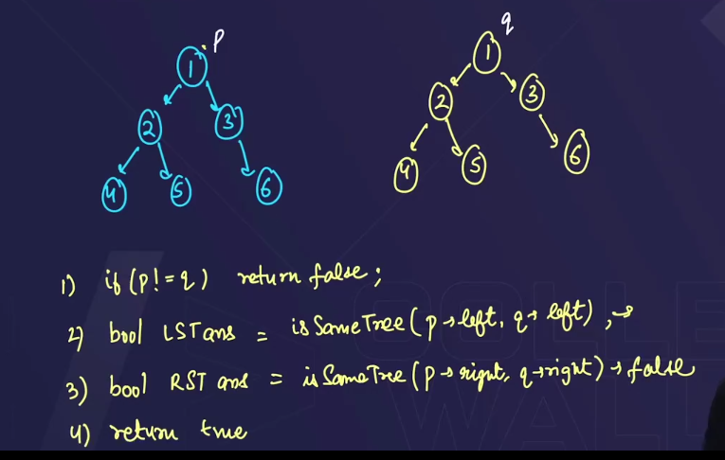 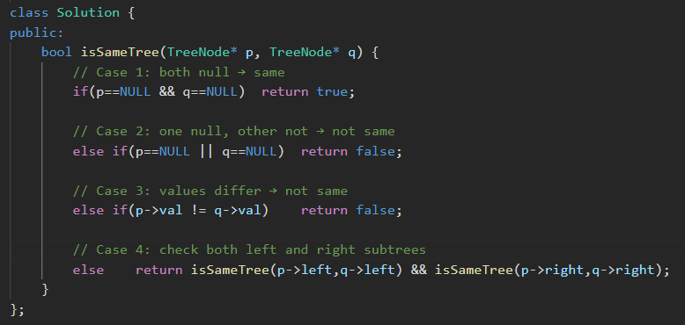

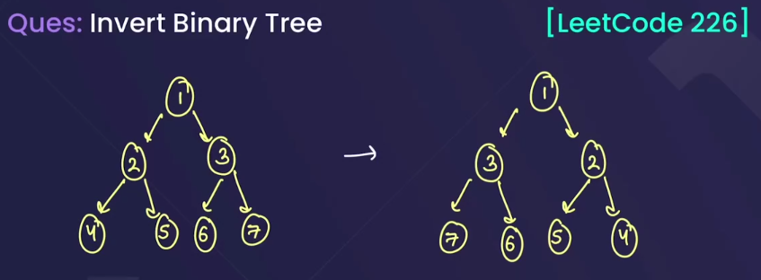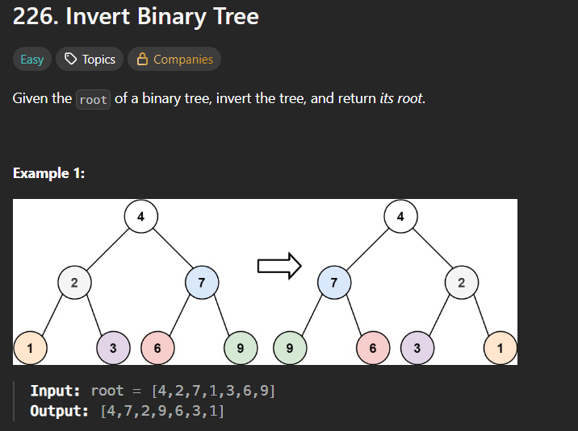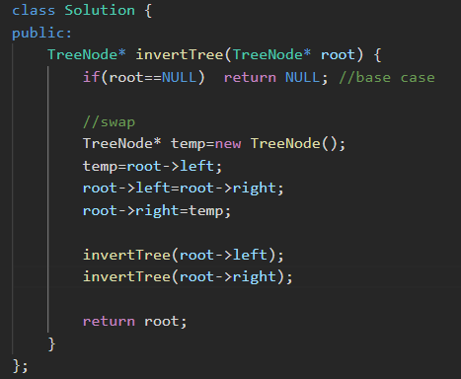

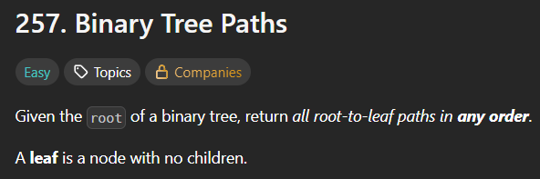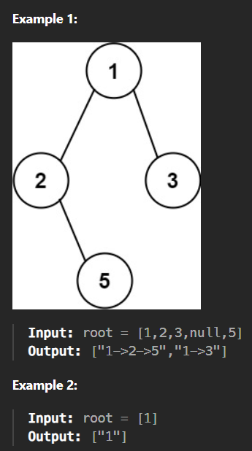

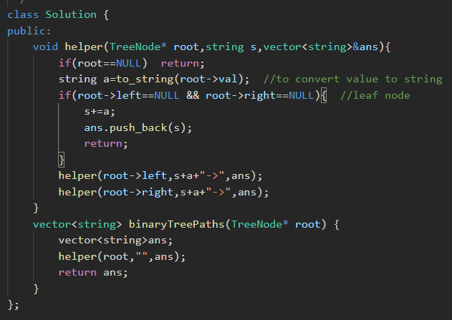

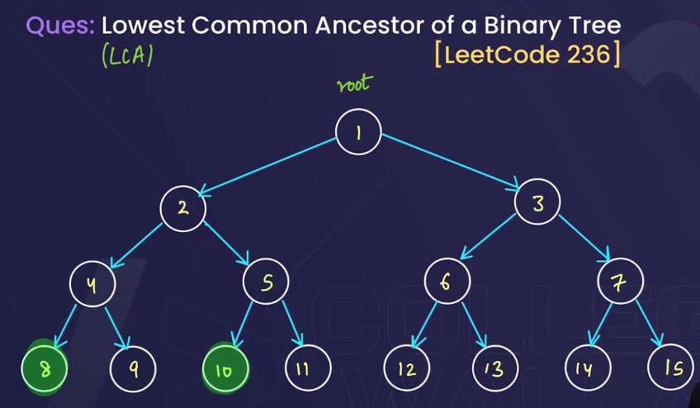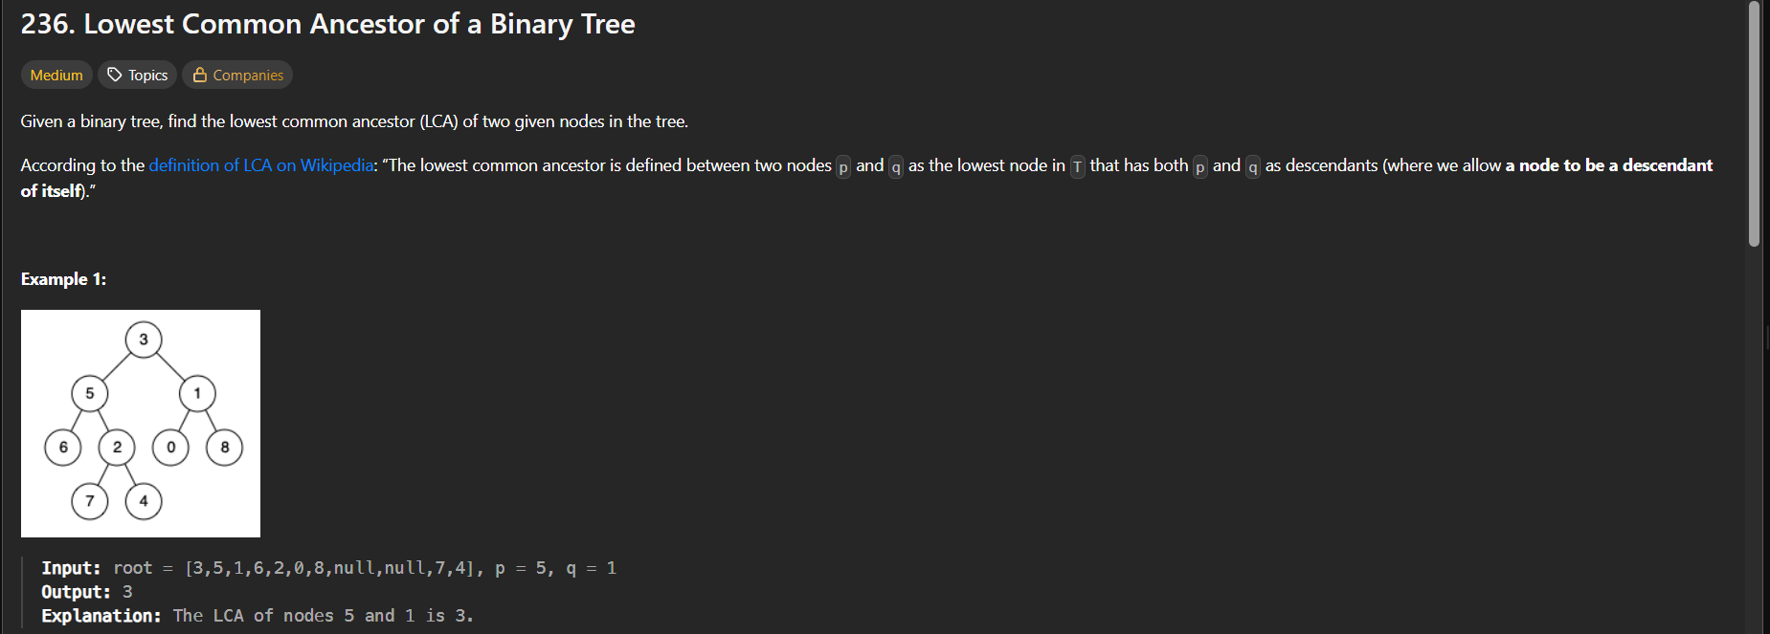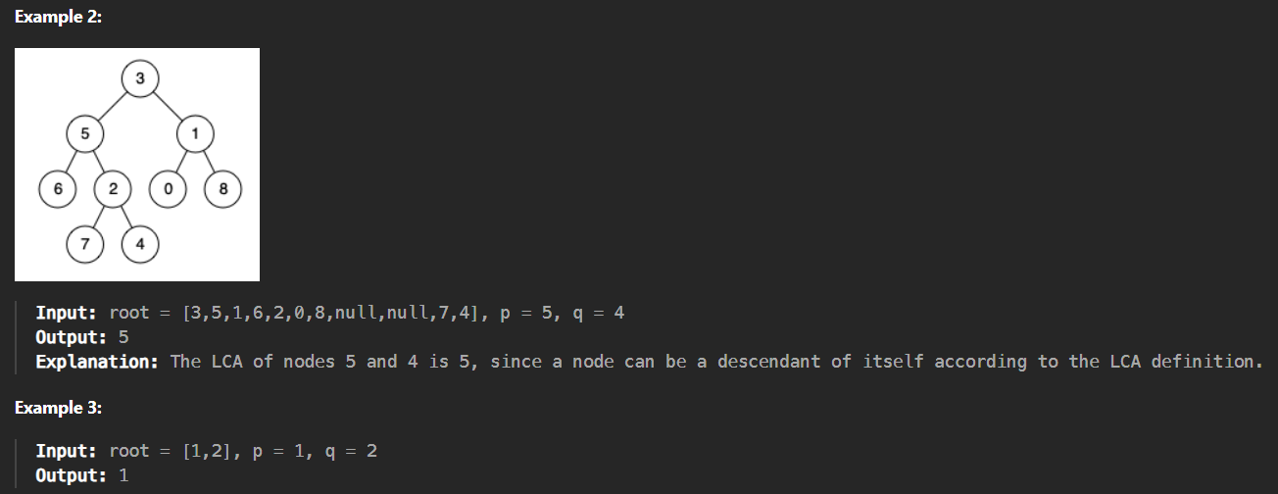

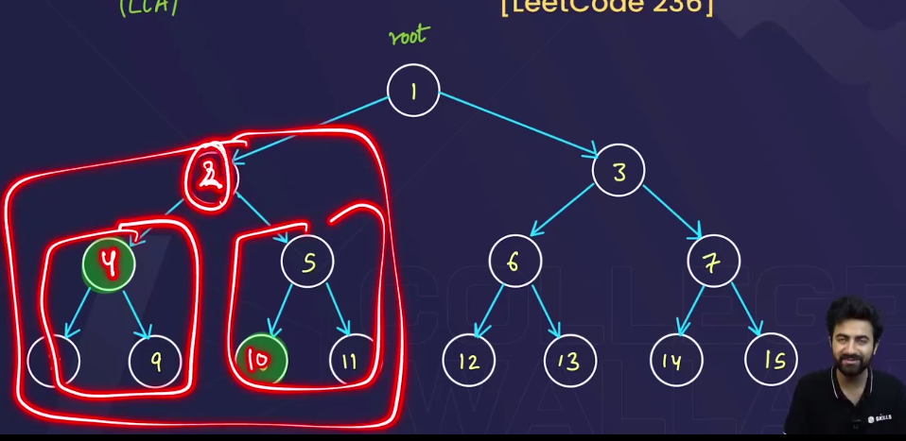🡪the root of the “p” and “q” will be the lowest common ancestor of the leftSubtree and the rightSubtree.

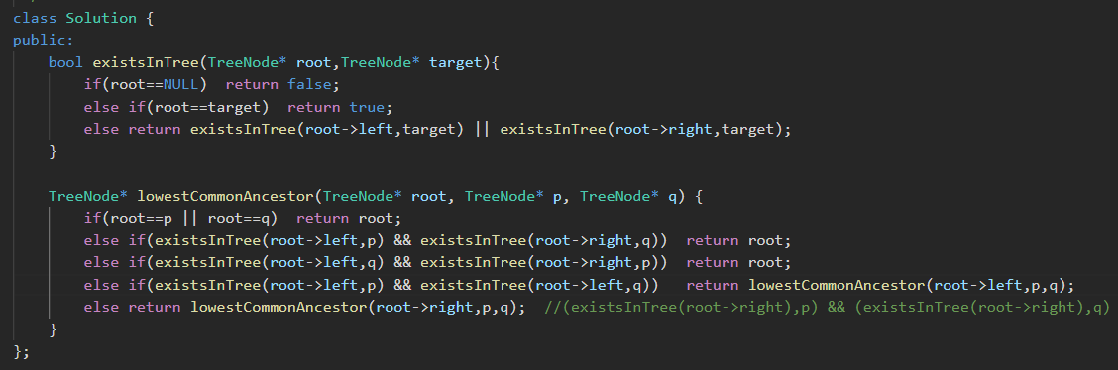



* We can also combine these statements becoz sbme root hi return krna h so we can add all three statements in the else statements.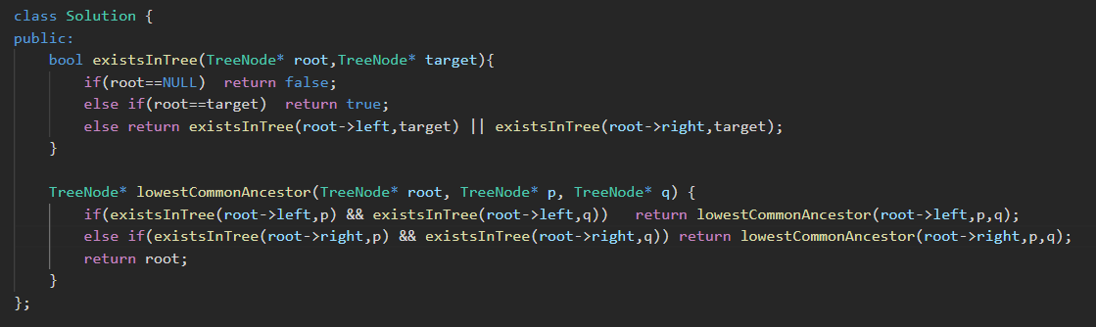

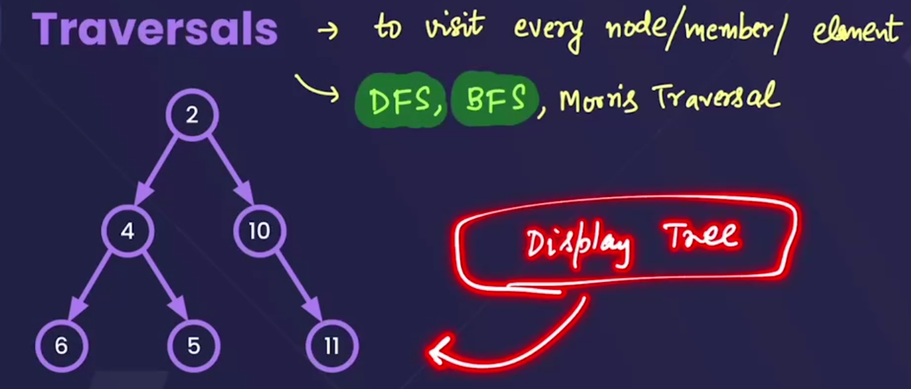

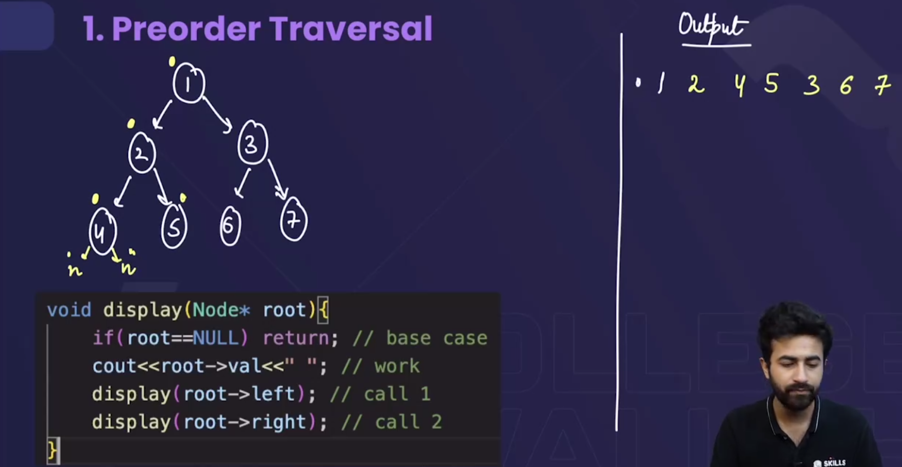

* ab tk hm jaise print krwaa rhe the tree ko , who **preorder Traversal** tha.
* 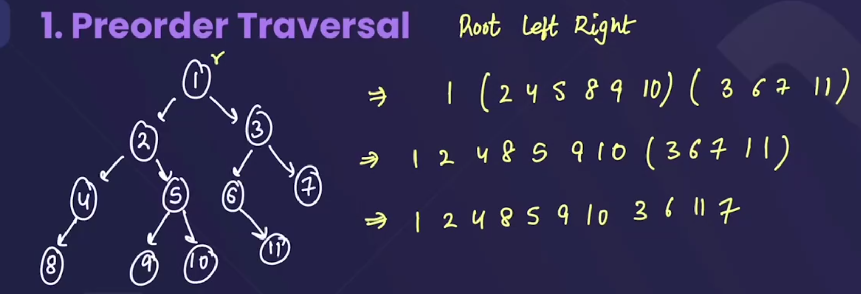
* 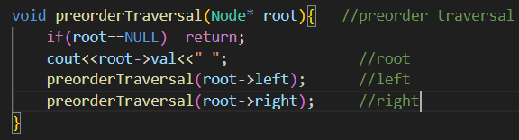
* Shortcut for preorder->called **Euler’s tree**🡪jb kissi node p hm **1st time visit** krenge while making euler’s tree then, uss node ko print krwaa do->preOrder Traversal 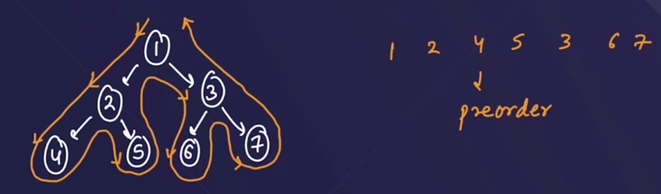

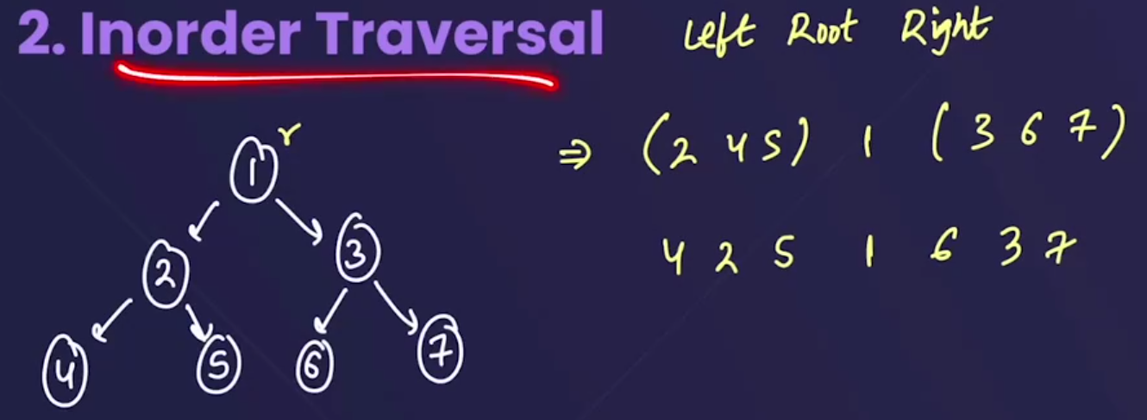

* 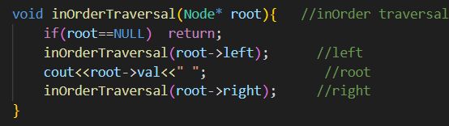
* Shortcut 1: for inorder->called **Euler’s tree** 🡪jb kissi node p hm **2nd time visit** krenge while making euler’s tree then, uss node ko print krwaa do->inOrder Traversal.

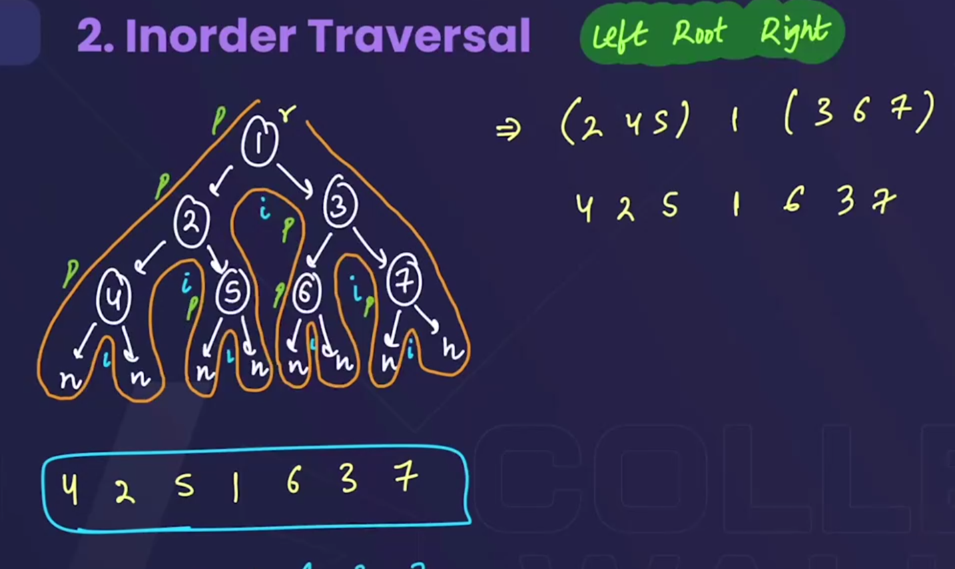

* Shortcut 2: for inorder->saare elements ko acche se tree m represent kro and sbke upar ek time bnaao, then jis line ka number pehle aayega usko print kro .

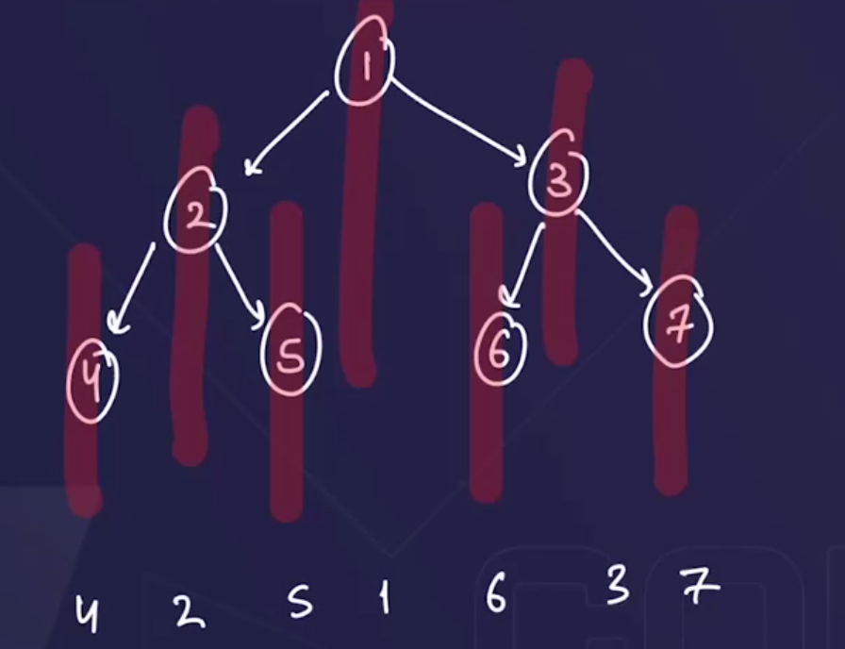

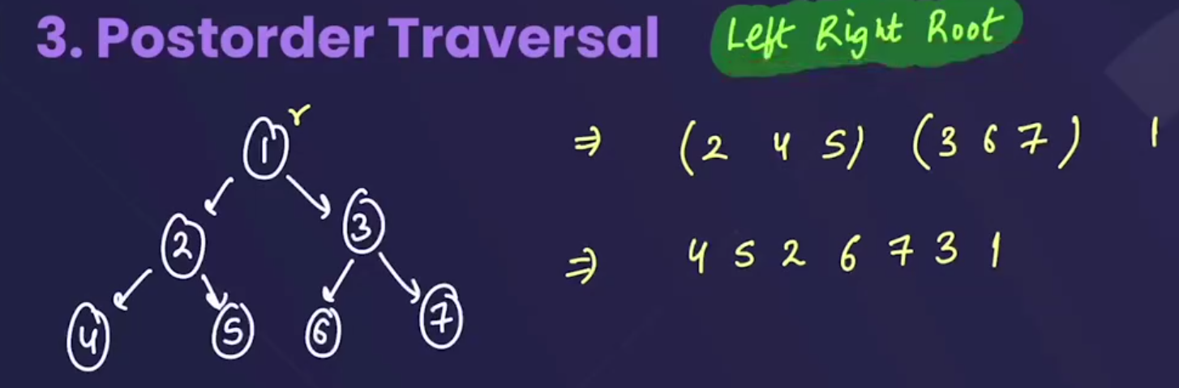

* 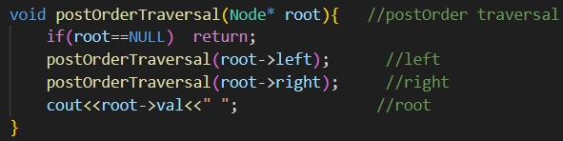
* Shortcut for postorder->called **Euler’s tree** 🡪jb kissi node p hm  **3rd time visit** krenge while making euler’s tree then, uss node ko print krwaa do->postOrder Traversal.

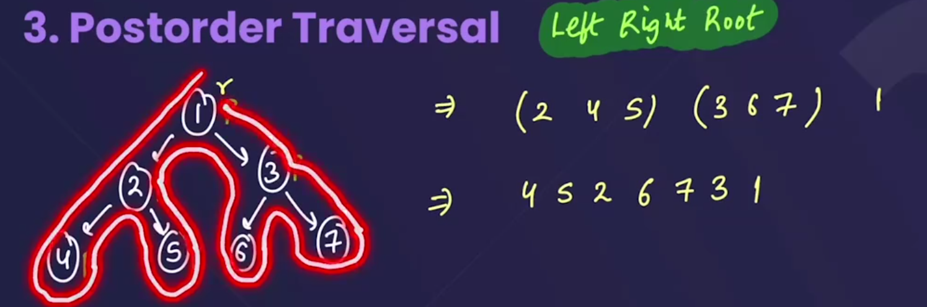

Note : the preorder, inorder and postorder traversals are the type of **DFS(depth first search).**

**# Time Complexity in case of all PreOrder,InOrder,PostOrder:**

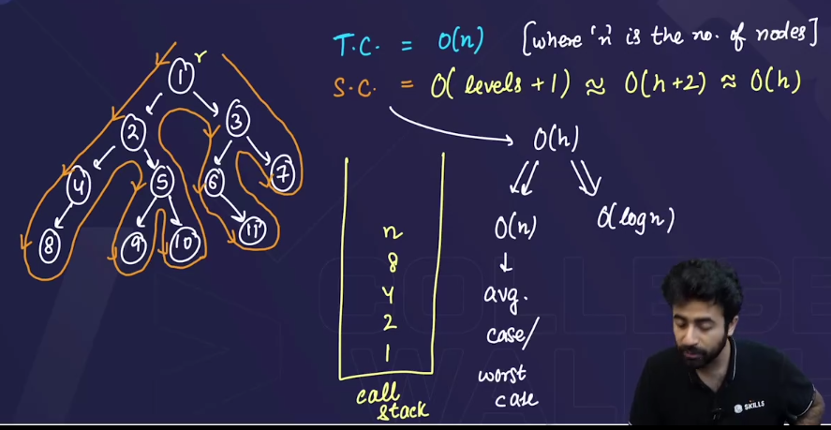

* Since we are reaching each and every node, to print , so the

**Time complexity=O(n)**

* For the space complexity🡪 call stack form hota h, and jb node print ho jaata h then node delete bhi ho jaata h🡪 so we will consider the maximum size used i.e

**Space complexity=O(no. of levels+1)** 🡪+1 for storing null

**=O(h+2)** 🡪since(no. of levels=Height+1)

**=O(h)**

* + Space complexity=O(n) 🡪in average and worst case. 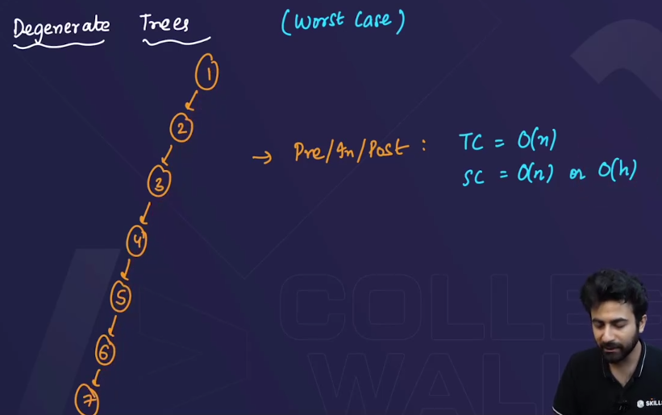
  + Space complexity=O(logn) 🡪in best case.

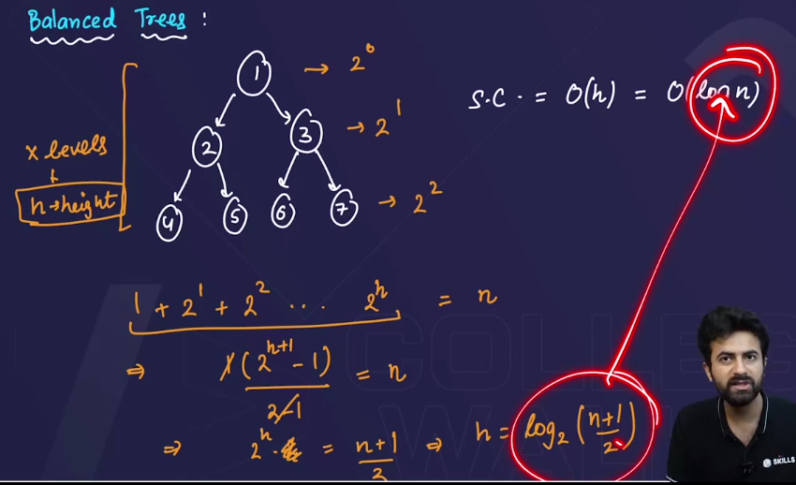

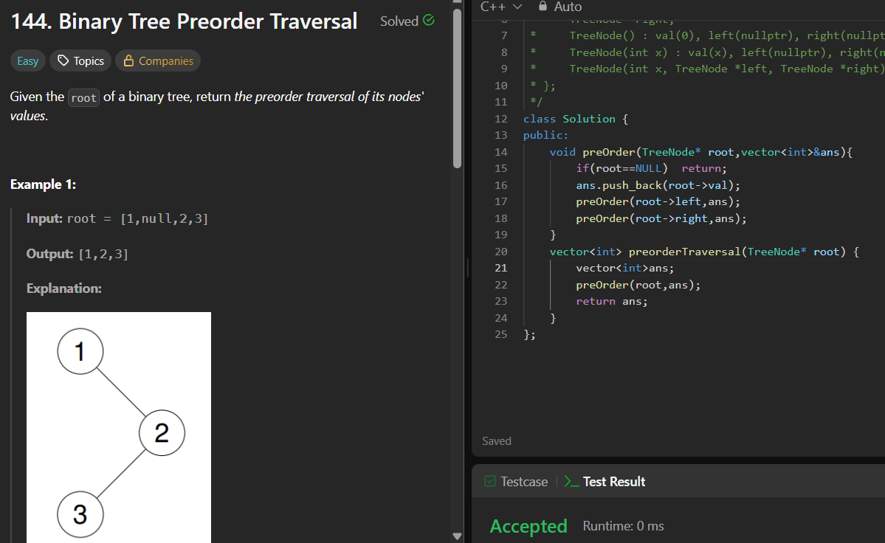

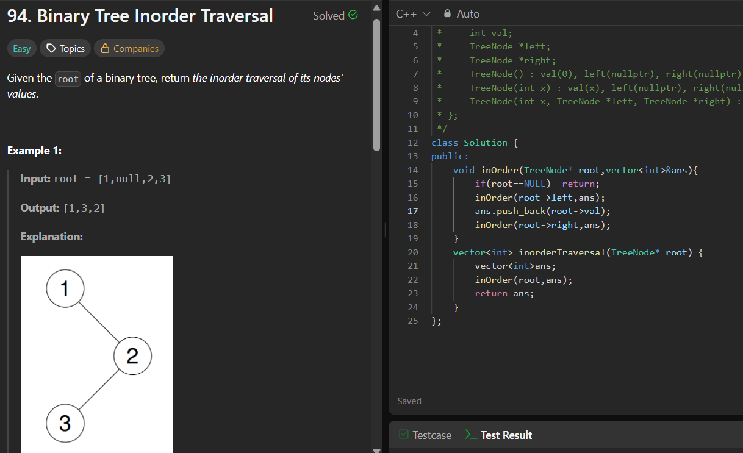

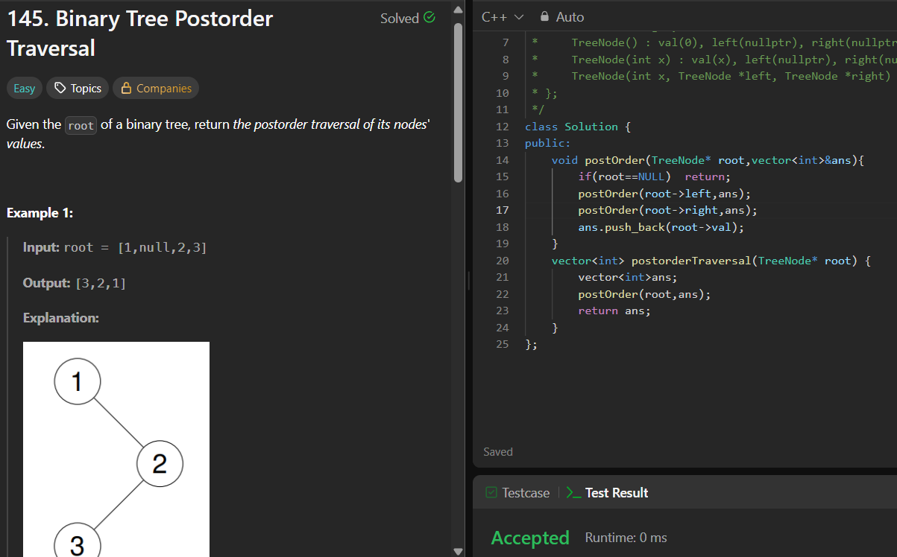

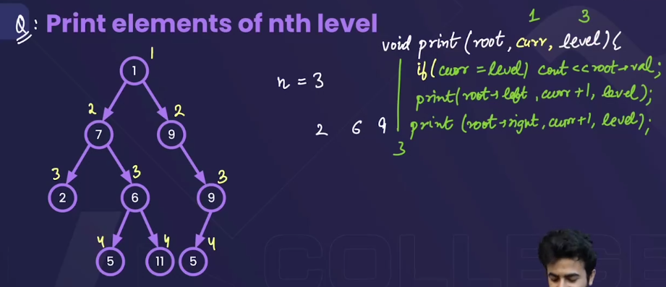 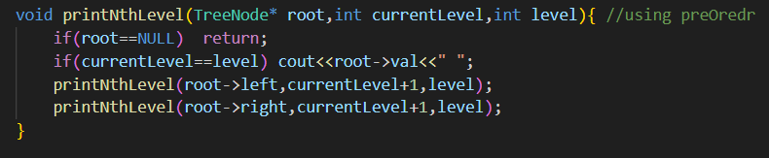 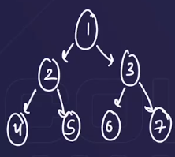 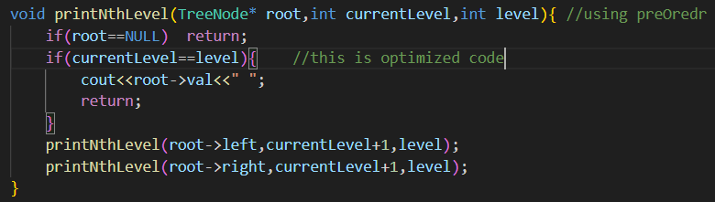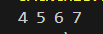



* This is not optimized code.
* This is optimized code.

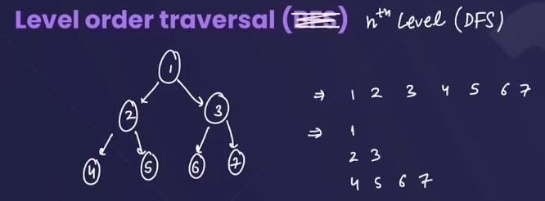

* In this question we have to print the elements level wise. 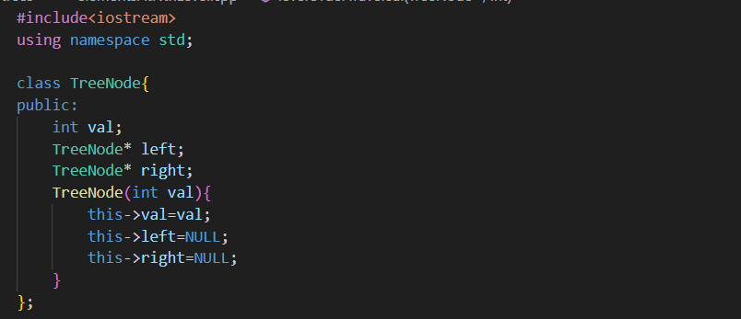
* 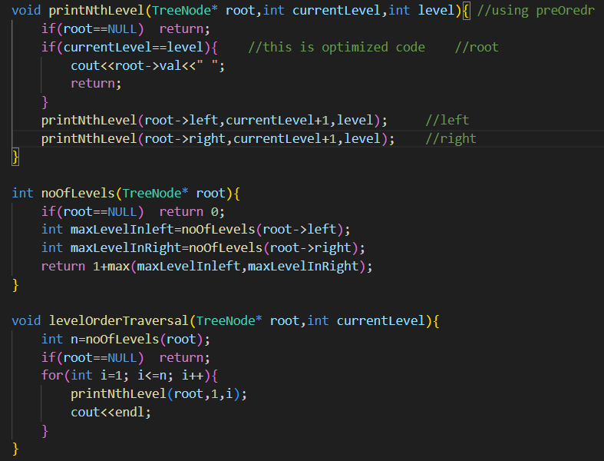

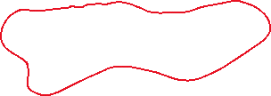

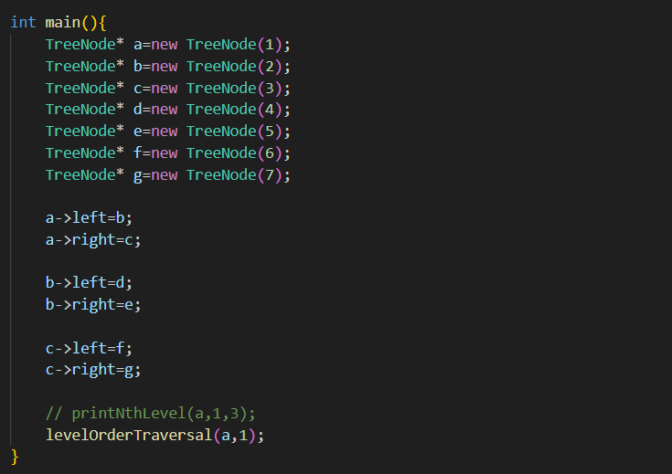 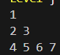

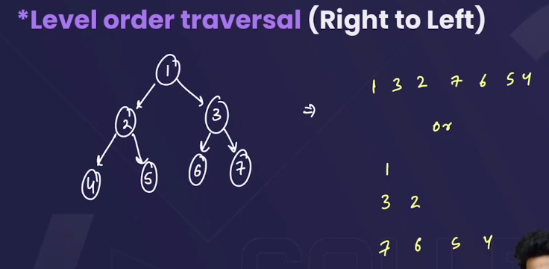🡪it is same as printing the elements from left to right(just above waala question), just we have to change in the printNthlevel() function, usme hm pehle right ko call krenge then , left ko , then we will get the tree in reverse order(we can use any of the traversal methods i.e preorder, inorder, postorder)

* 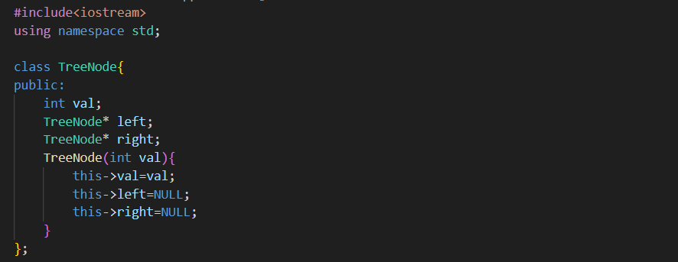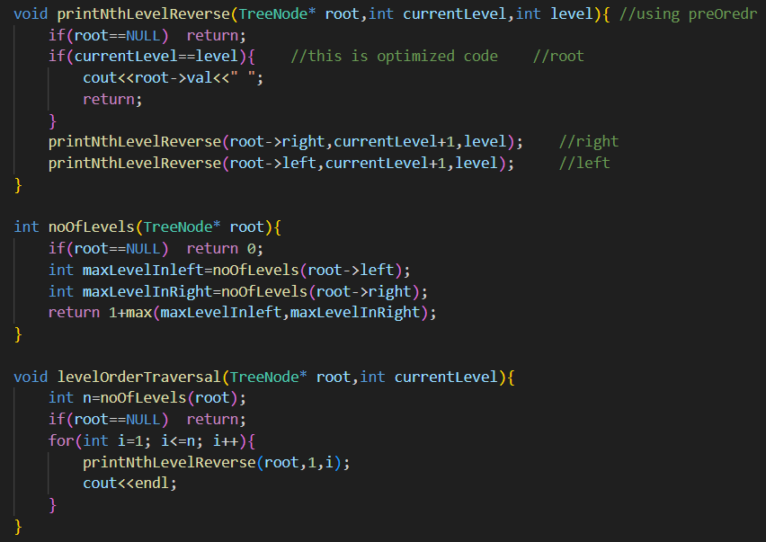

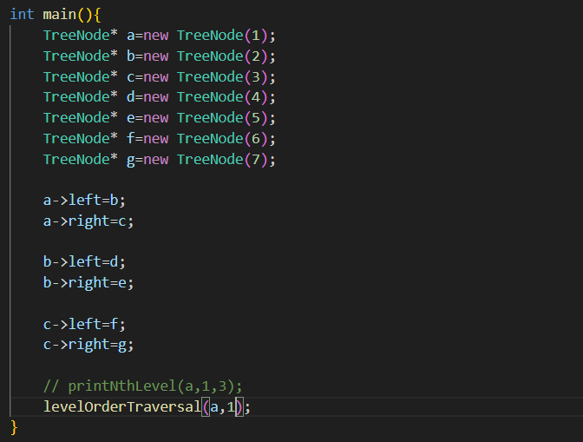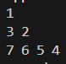

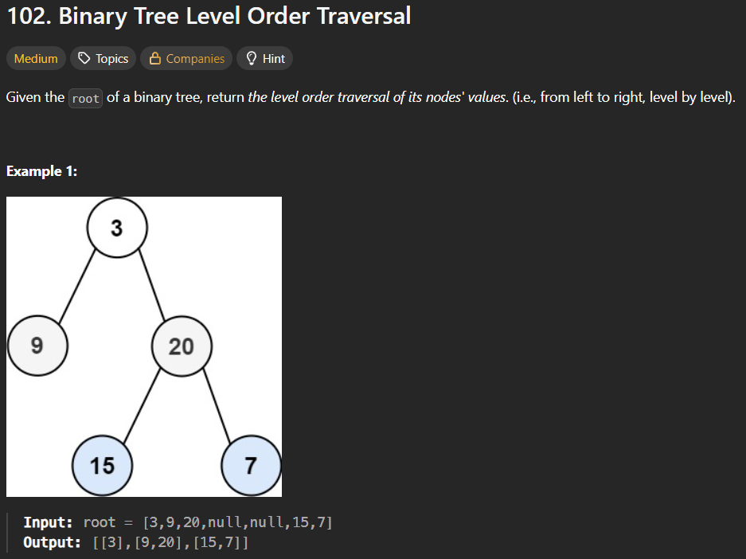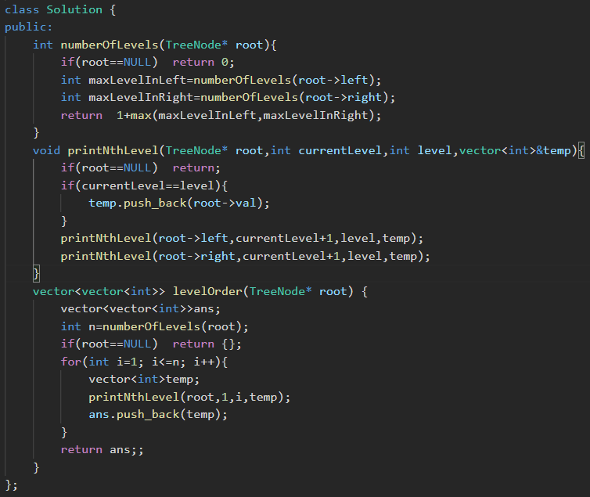

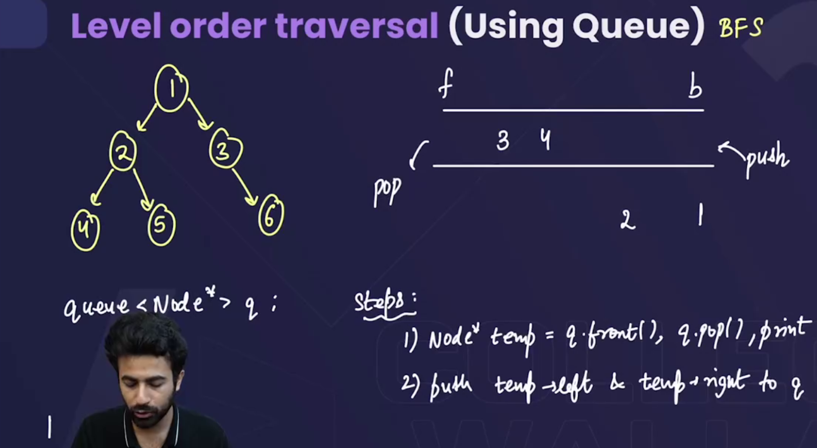

* The level order traversal using a queue is called **BFS**. 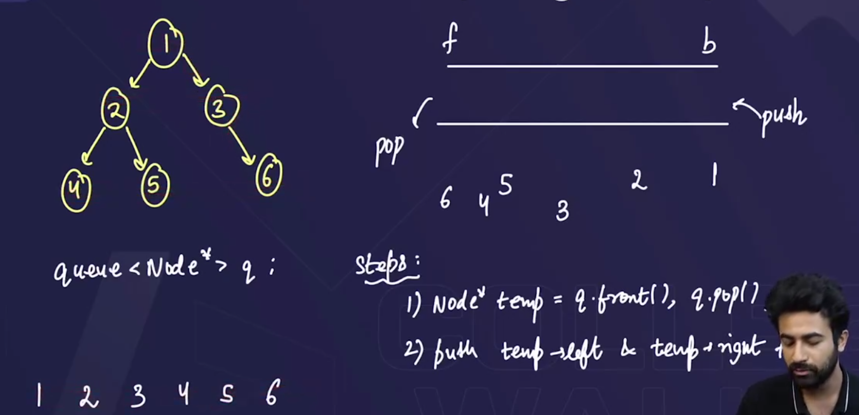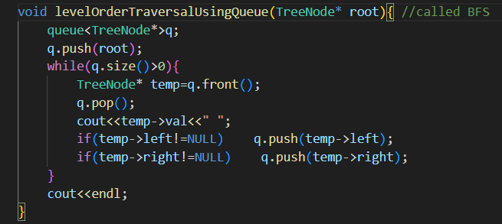



* **BFS is the easiest way to traverse a tree.**

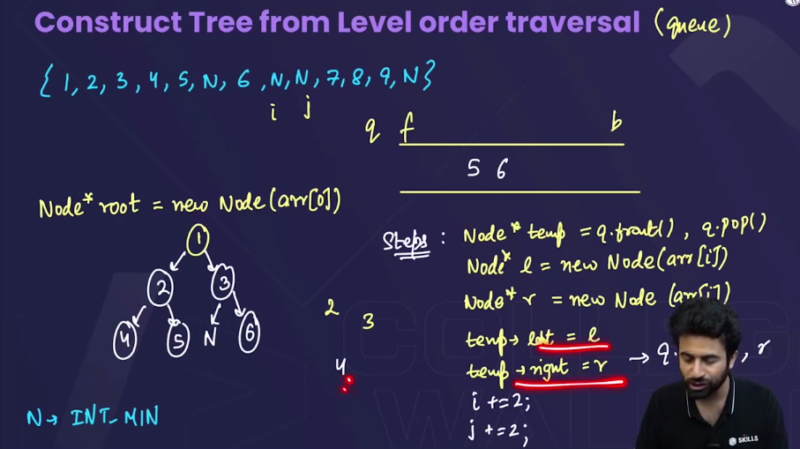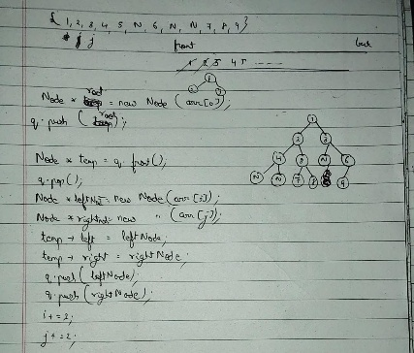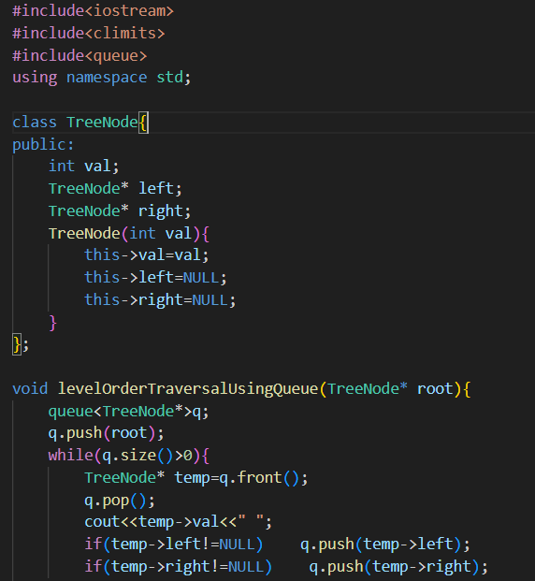

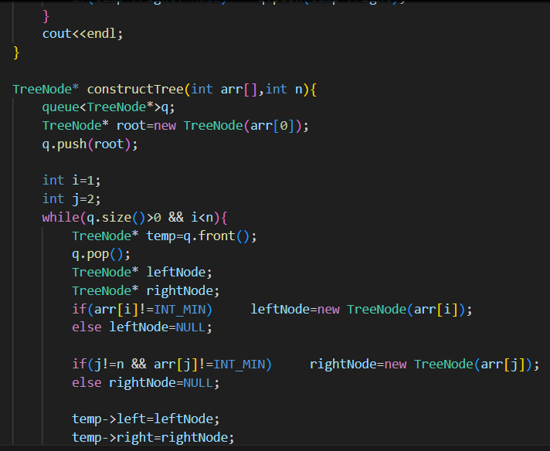

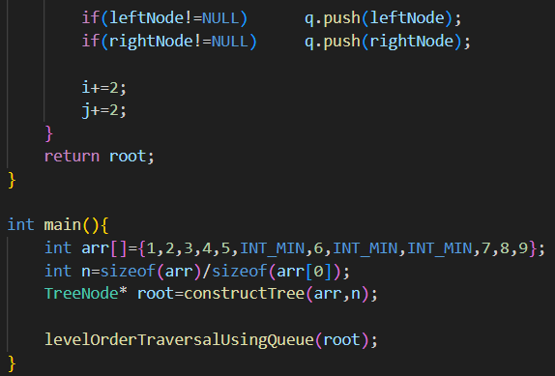



* Abhi tk hm jaise traverse kr rhe the who by using recursion tha but now we will do traversal using Iteration (loops). 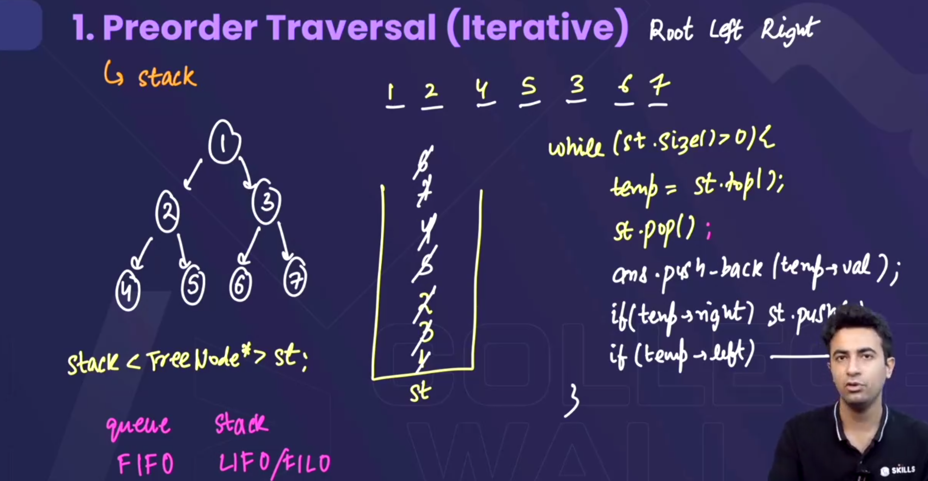
* In the iterative form of “preorder traversal” using loops we use a stack,
  + Is stack m hm pehle root ko push krwa denge , then pop() kewa k usko print krwaa denge(answer array m daal denge).
  + Then uske baad hm **root->right waale node ko pehle stack m push krenge, then left waale ko, becoz stack m jo upr hoga who pehle print ho jaaygega**. 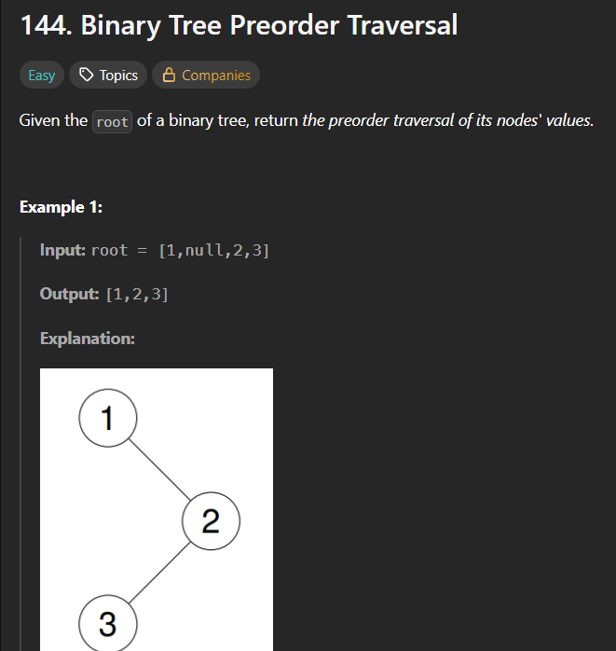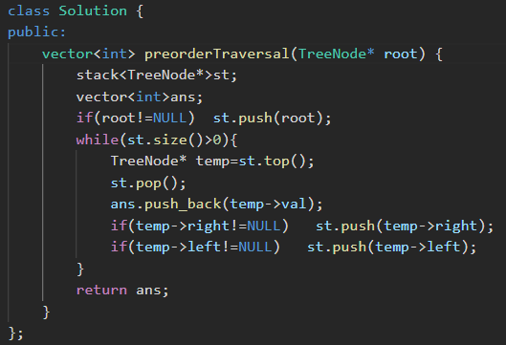

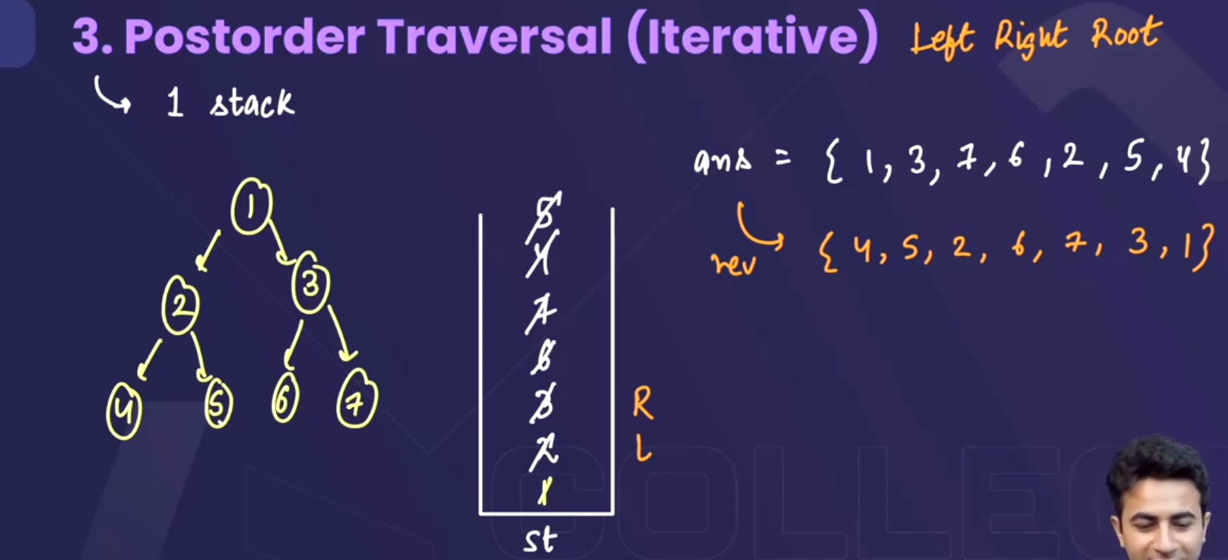

* In the iterative form of “postorder traversal” using loops we use a stack,
  + Is stack m hm pehle root ko push krwa denge , then pop() kewa k usko print krwaa denge(answer array m daal denge).
  + Then uske baad hm **root->left waale node ko pehle stack m push krenge, then right waale ko**.
  + Last m answer array ko reverse krwaa denge. 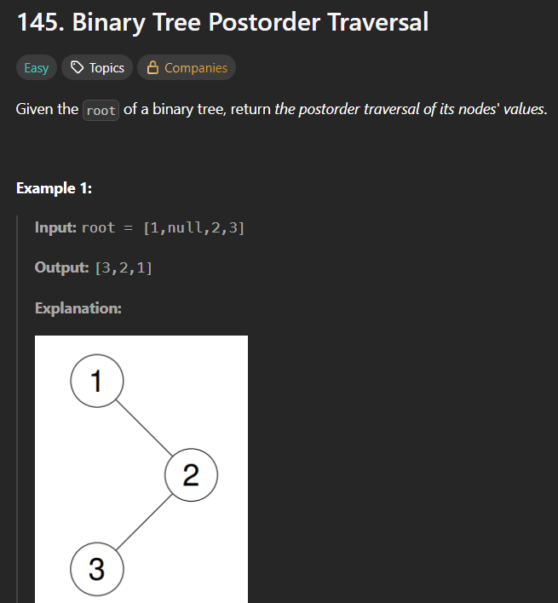 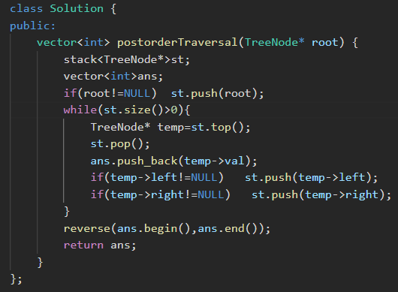

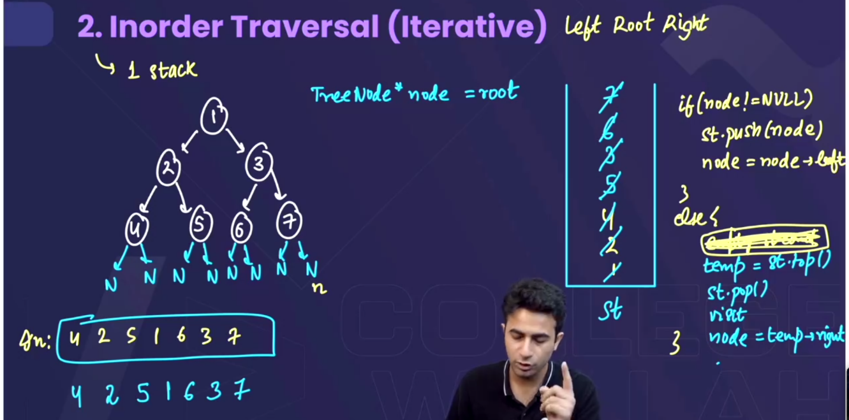  
=> 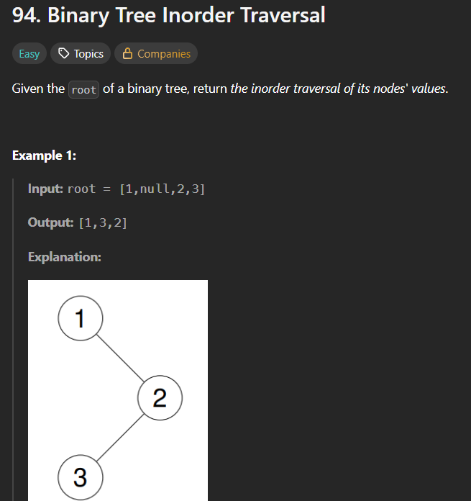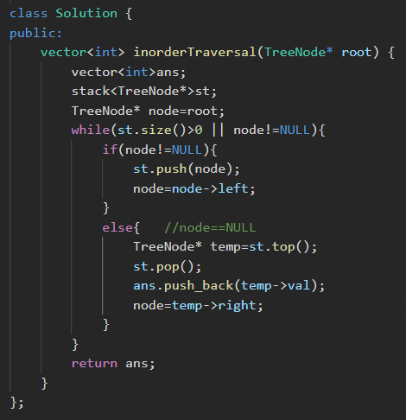

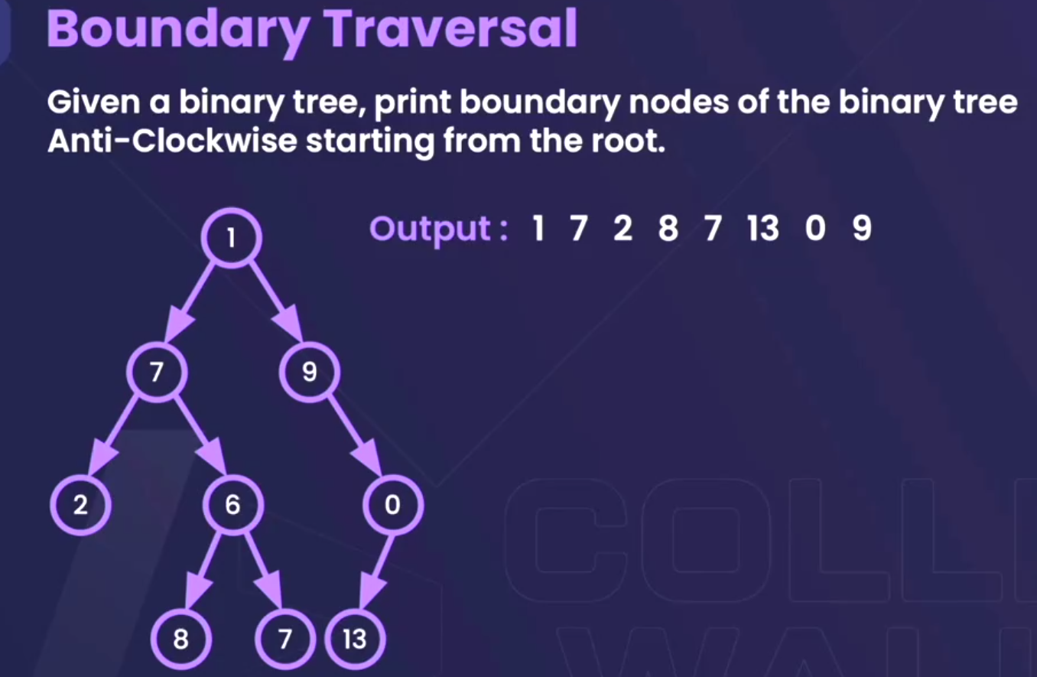

* 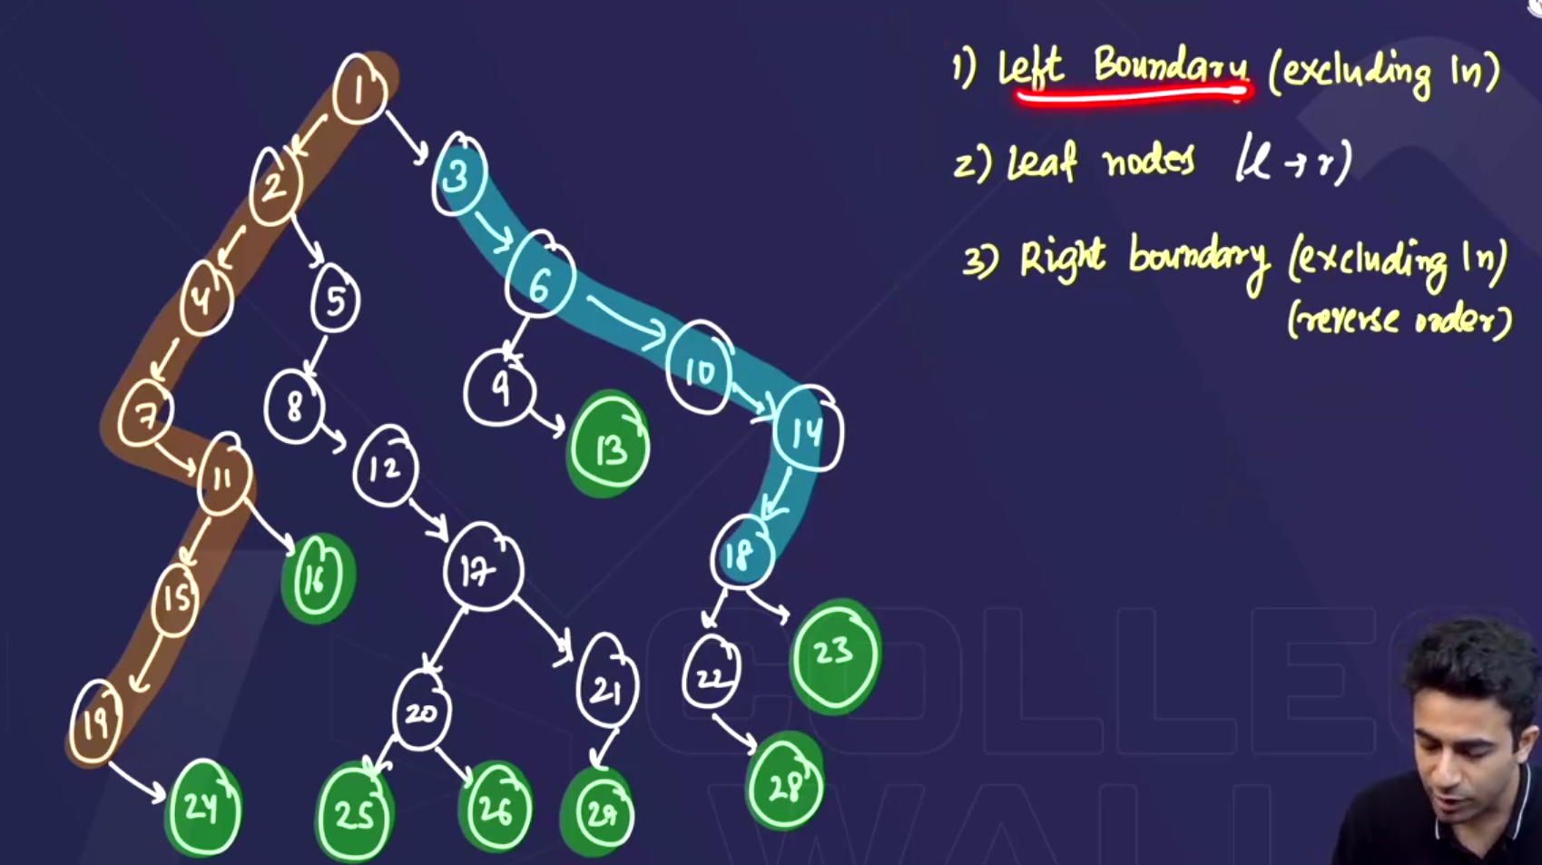
* In this question we have to print the boundary elements. So this question can be divided into 3 parts.
  + 1st print the left boundary nodes(excluding the leaf nodes)🡪represented by brown colour.
  + 2nd print the leaf nodes🡪represented by green colour.
  + 3rd print the right boundary nodes in reverse order(excluding the leaf nodes)🡪represented by blue colour.
* 1st lets construct this tree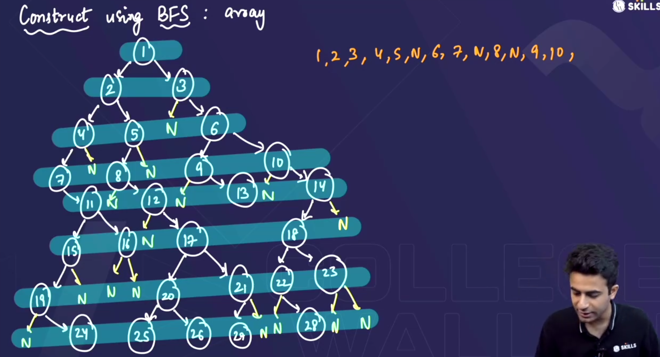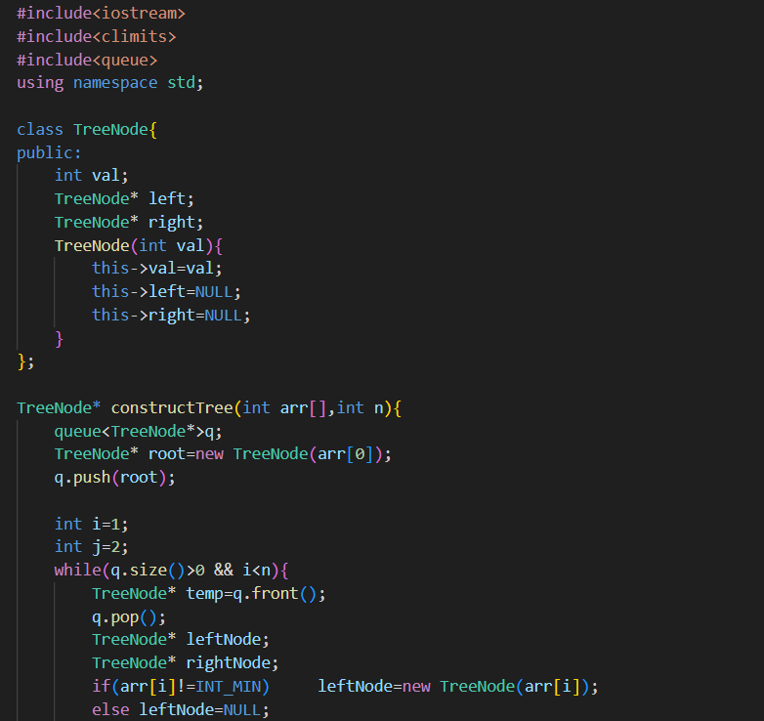
* 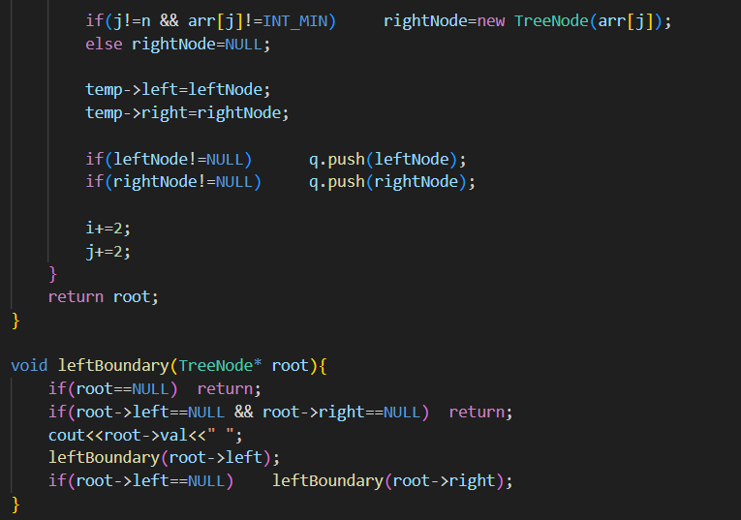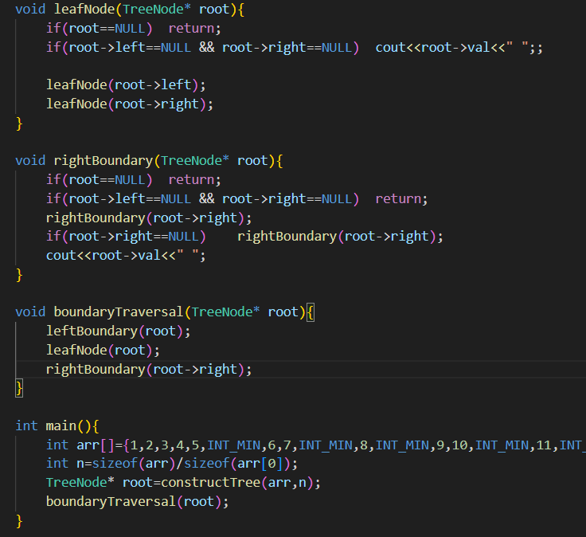

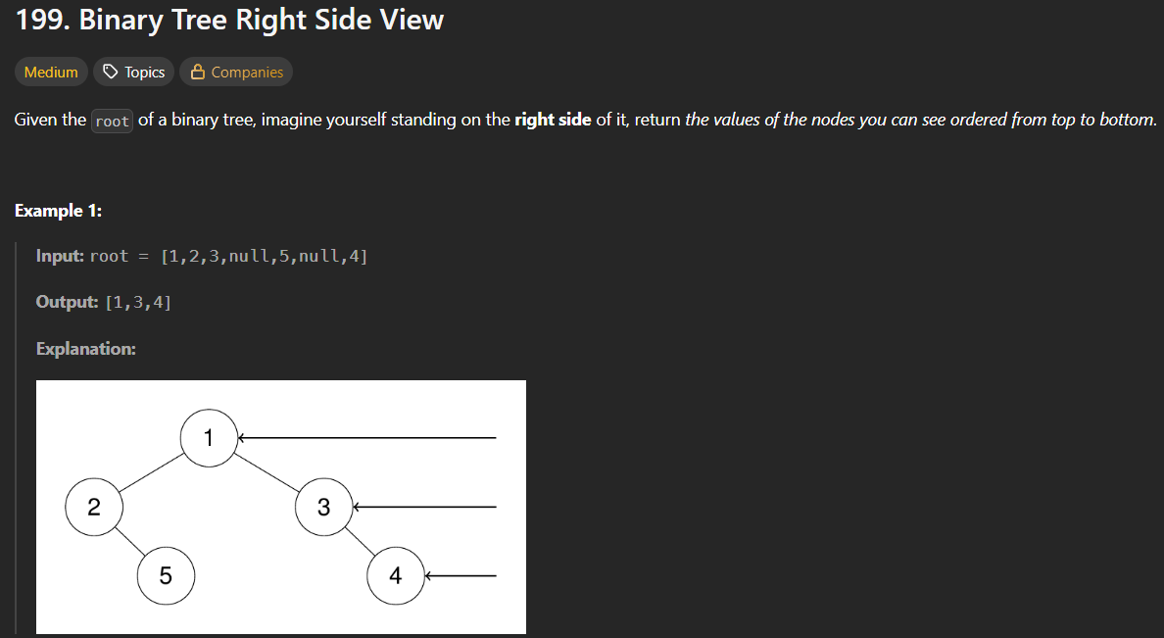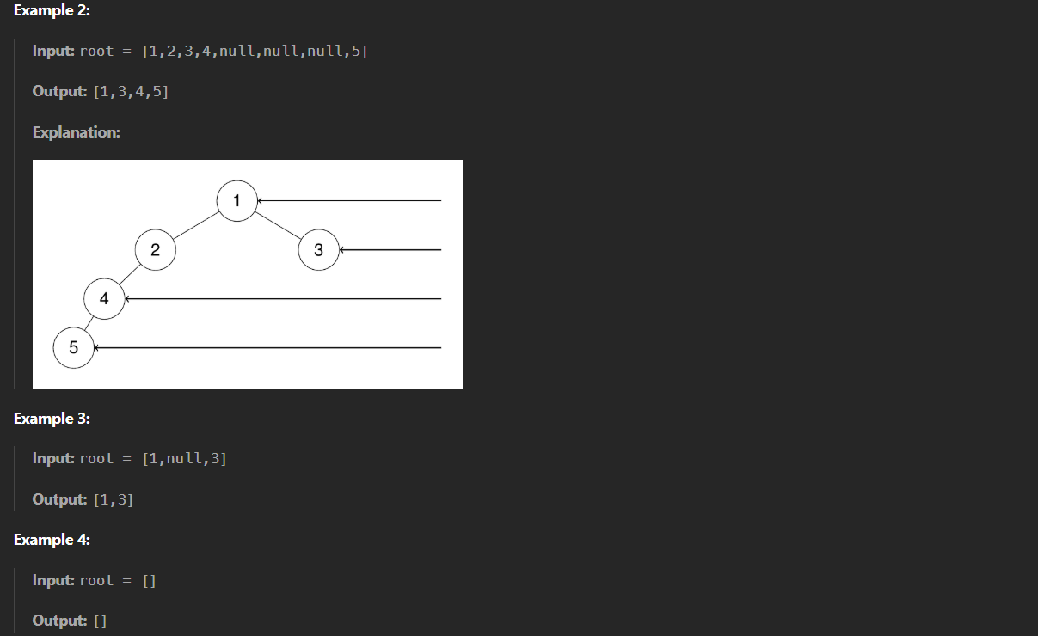

**Hint:** print the rightmost element of each level.

* 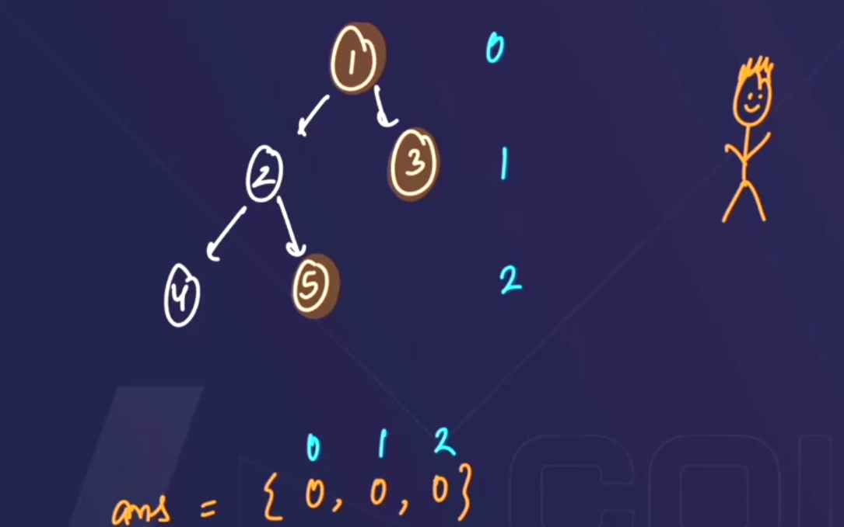
* **No. of levels** pta kr lo then, utne hi size ka ek vector bna lo , and then rightmost element ko vector m push krwa do.
* **Method 1**

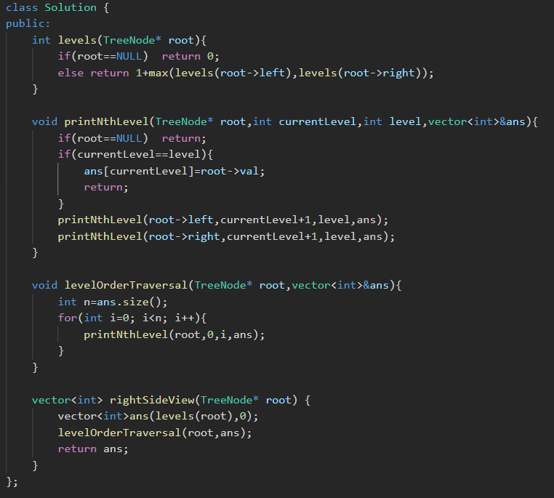

* **Method 2** (easier)

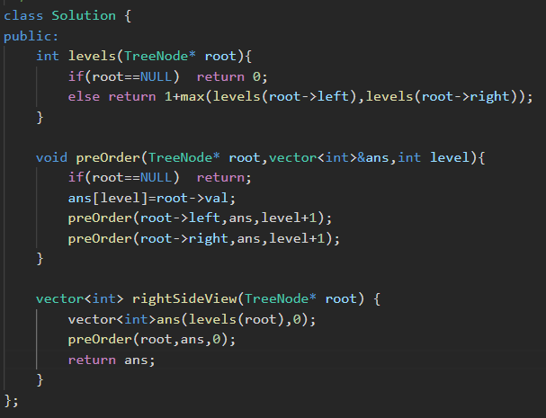

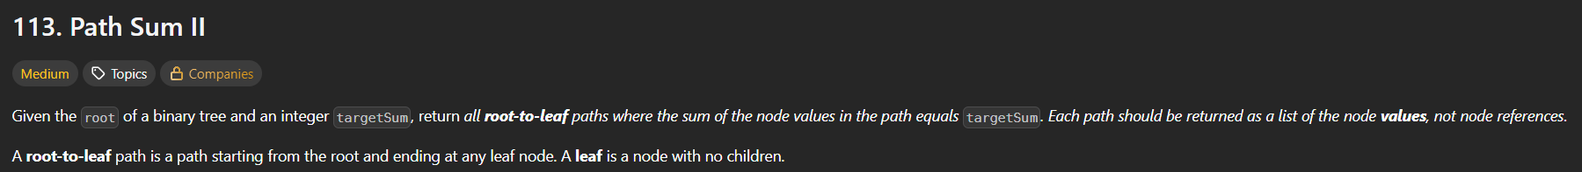 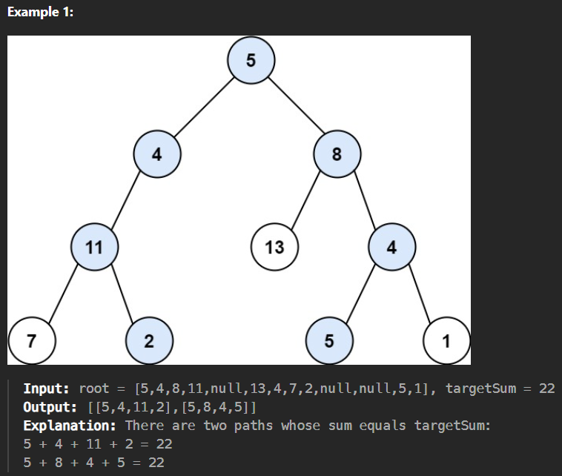 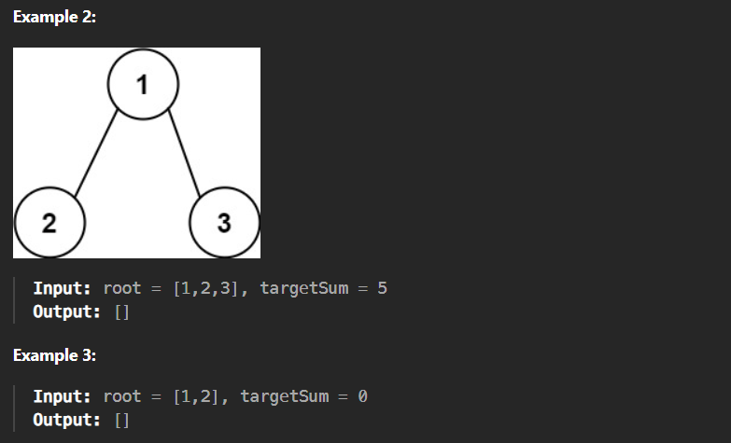 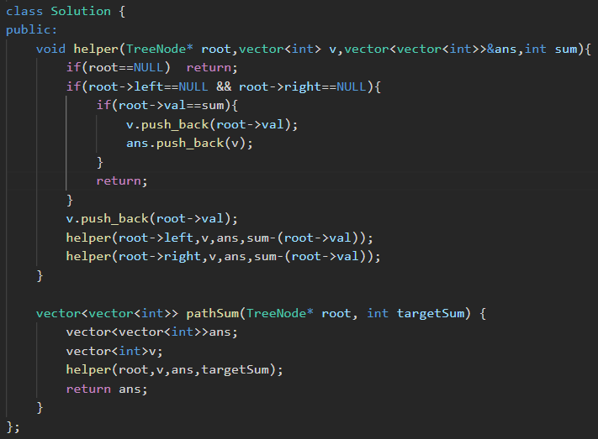

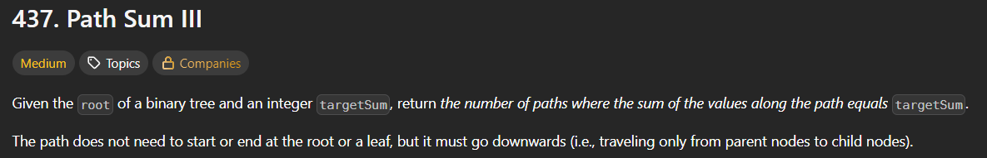 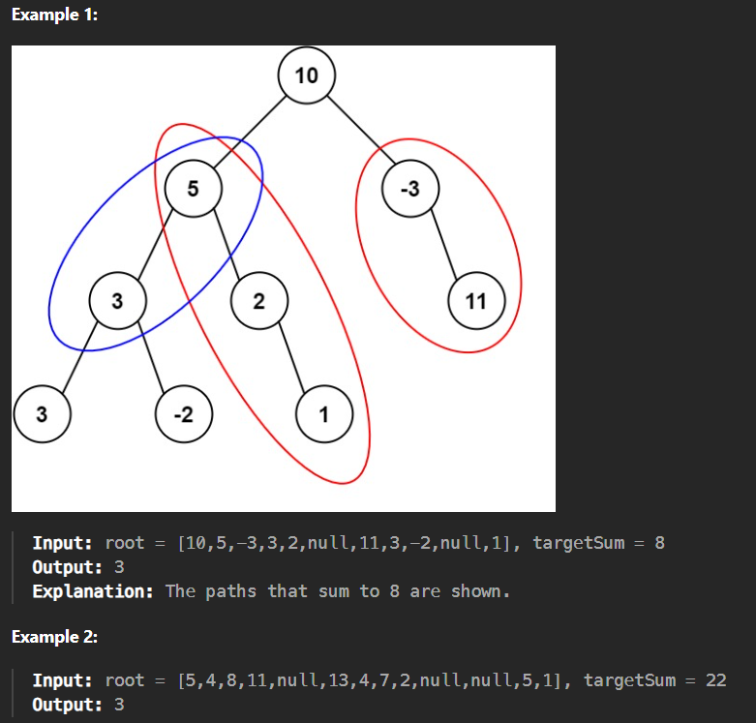

* In **Path Sum II (leetcode 113)** question helper function was called for only the root, but here we will call the helper function for every node (becoz yha restriction nhi h ki path root se hi start hona chahiye). 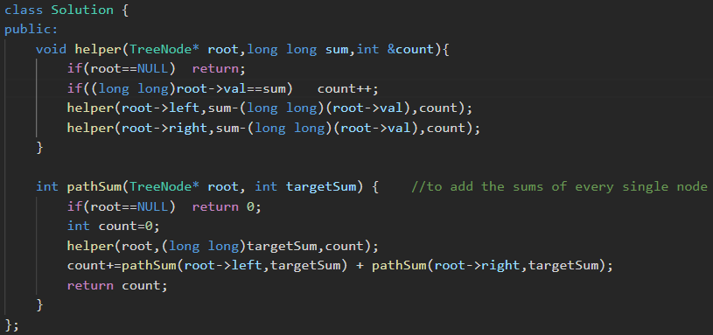

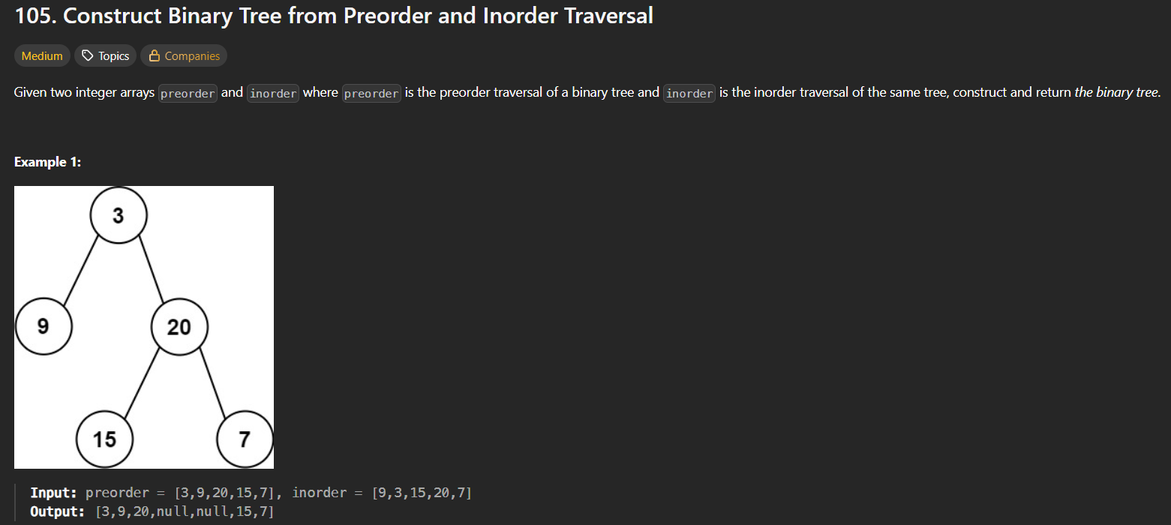 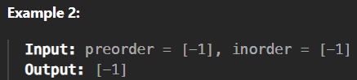

* Agar sirf ek preorder ya inOrder sequence se hm multiple trees generate kr skte h 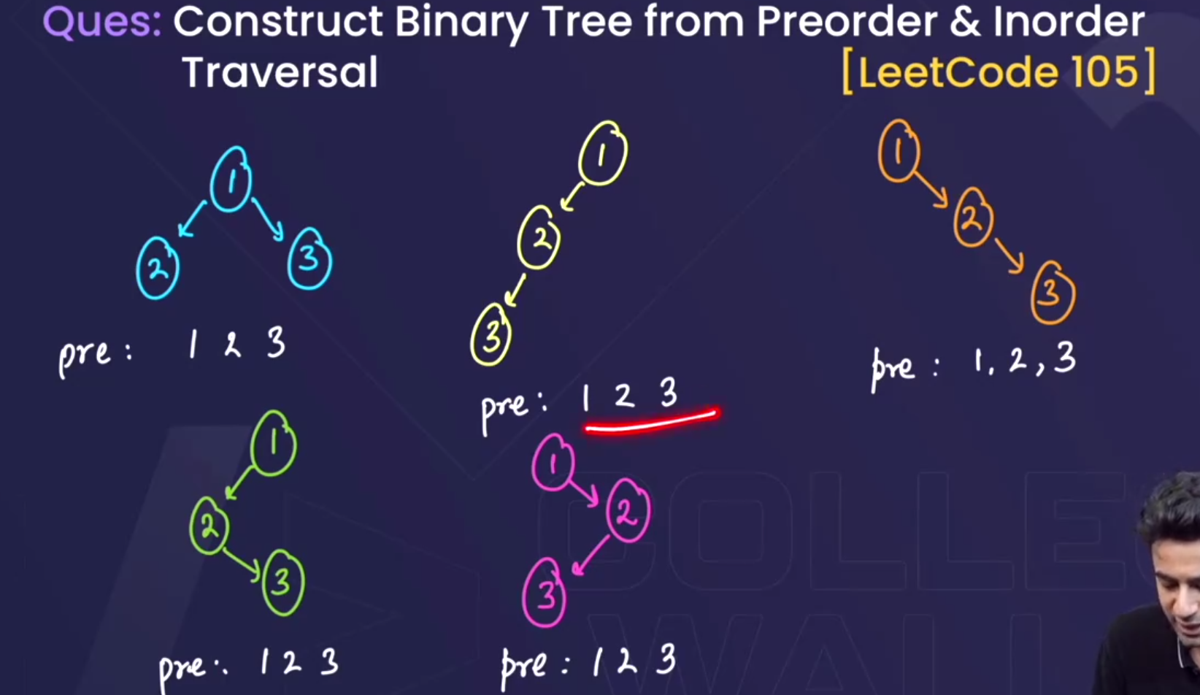 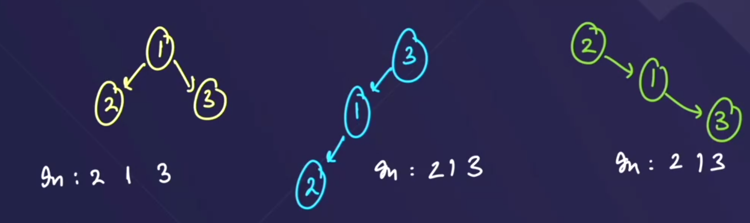
* But preOrder and inOrder and postOrder , tino m se koii bhi 2 diya rhega then usse koii ek unique tree hi form ho skta h



 